Phytoplankton growth regulation by dissolved P and mortality regulation by endogenous cell death over 35 years of P control in a mountain lake

William M. Lewis, Jr. ^{1,2} and Jennifer Roberson ¹

¹ Center for Limnology, Cooperative Institute for Research in Environmental Sciences, 216 UCB, University of Colorado, Boulder, CO 80309-0216, USA

² Department of Ecology and Evolutionary Biology, 334 UCB, University of Colorado, Boulder, CO 80309-0216, USA

Corresponding author: William.Lewis@colorado.edu; phone 303-492-6378; fax 303-492-0928
Abstract
Lake Dillon was studied for physical and chemical variables and plankton dynamics beginning two years prior to an aggressive P control program in 1981 and extending thereafter for 35 years. Lake Dillon provides an example of early intervention for P enrichment rather than remediation of advanced eutrophication. Watershed phosphorus control began with tertiary treatment of effluent, which caused a rapid decline in algal biomass from 8.1 to 4.5 μg L⁻¹ chl a. Change in total P loading was not significant statistically; phytoplankton suppression was caused by reduced load of bioavailable P (BAP), which was dominant in municipal effluent that was treated for P removal. A further phytoplankton response (4.6 declining to 2.5 μg L⁻¹ chl a) occurred later following replacement of failing septic systems that caused further reduction in BAP. A strong relationship between BAP loading and suppression of phytoplankton showed that BAP, rather than total P, was the only viable index of nutrient control for phytoplankton biomass in the lake. Also, phytoplankton composition changed greatly over the study interval, even though there was no secular change in causes of phytoplankton abundance other than reduction in BAP; gradual decline of P appears to have been the cause of large interannual changes in phytoplankton community composition. Factors typically assumed to control phytoplankton mortality (grazing, hydraulic removal of biomass, sinking) accounted for only ~50% of phytoplankton biomass turnover; the balance of mortality was accounted for by endogenous cell mortality of unknown cause.

Keywords: phytoplankton biomass control, algal community composition, endogenous cell mortality, oligotrophication, lake phosphorus loading

Introduction
Lake Dillon was created in 1963 as a water supply for the City of Denver by impoundment of the Blue River near the US Continental Divide in Summit County, Colorado (volume at spillway level 0.317 km³; elevation 2748 m amsl; area 13.35 km²; mean depth 24.1 m; watershed area 85,160 ha; Lewis et al. 1984). The lake stores water from the Blue River and two of its tributaries, the Snake River and Tenmile Creek (Figure 1). The headwaters for the three rivers reach the Continental Divide at a maximum elevation near 4300 m amsl.
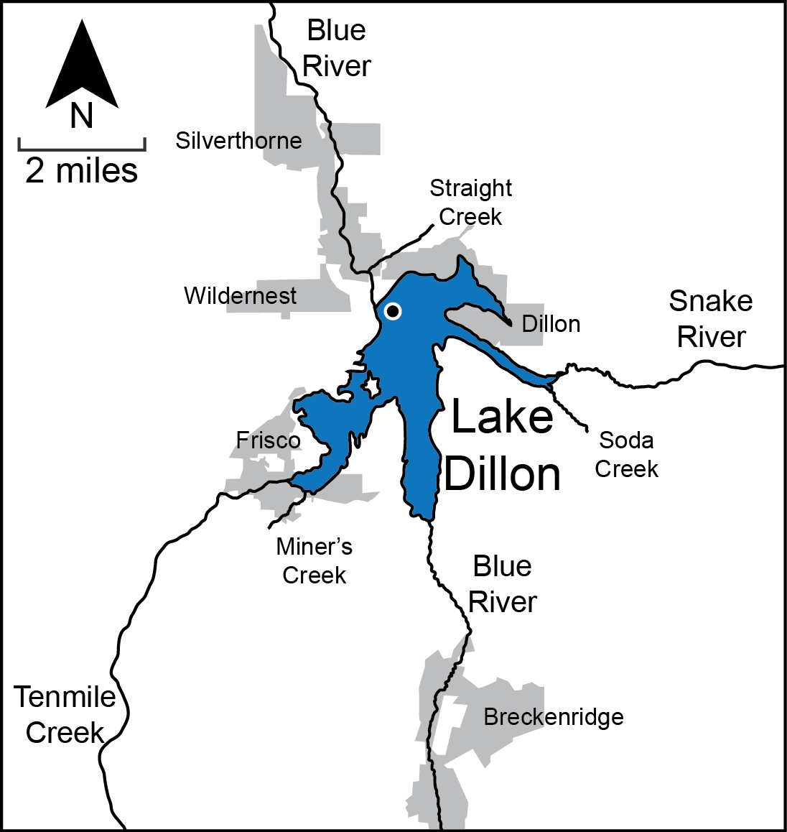
Figure 1. Map of Lake Dillon and surrounding areas. The circle indicates location of the index station, over deepest water. Copper Mountain resort is located on Tenmile Creek south of the map margin.
Water is conveyed from Lake Dillon to Denver through a transmountain tunnel with a withdrawal point approximately 53 m below the reservoir surface. Water that cannot be stored is released to the Blue River below the dam (~50 m below spillway level), which has a minimum conservation flow of 1.42 m³ s⁻¹. In addition, water passes over the spillway during the runoff season (June, July) most years.
The watershed of Lake Dillon consists largely of coniferous forest but also includes extensive area above treeline and wetlands along the three rivers. Development of the watershed is based on the ski industry, which is associated with four small municipalities (Figure 1).
The USEPA and the State of Colorado in 1983 designated Lake Dillon for special protection of water quality in recognition of its scenic character as well as its importance to the Denver water supply and the recreational value of the lake and its watershed. Water quality control was implemented through a phosphorus concentration standard for the upper water column of Lake Dillon (7.4 μg L⁻¹ total P) and an associated requirement for control of phosphorus export from the watershed by use of a total loading limit corresponding to the status quo of loading in 1982 along with formal arrangements for the use of phosphorus recovery projects to generate a quantifiable phosphorus bank to be used in accommodating further development of the watershed. All wastewater treatment facilities in the county were required to use tertiary treatment for control of phosphorus and land use practices were adopted within the watershed for the purpose of controlling nonpoint source pollution of the reservoir by phosphorus.
The Lake Dillon watershed was experiencing rapid development when the water quality regulation was adopted in 1983; the resident population then was 19,000 and seasonal peak population was 85,000. Development continued subsequently, but at a slower pace (present resident population 30,000; seasonal 160,000). Continuous studies of the lake and watershed from 1981 to 2016 provide the basis for an analysis of the response of the lake to the phosphorus control regulation.
The long data record and numerous intensive studies of specific processes for Lake Dillon provide a basis for analyzing an unexpected long-term response of phytoplankton to the nutrient control regulation of Lake Dillon. The control regulation was intended to prevent the annual load of phosphorus for Lake Dillon from rising in response to population growth. The 35-year data record shows that control of P did result in stabilization of total P loading, which was expected to cause corresponding stabilization of algal biomass, but phytoplankton biomass continued to decline for decades after total P load was stabilized. The purpose of the present analysis is to use the long term data record to test hypotheses that might explain the unexpected 30 year decline in phytoplankton biomass. The long record also provides a basis for analysis of other lake features including fate of phytoplankton dynamics and changes in plankton composition.
Reduction in nutrient loading of lakes, primarily focusing on P, has been extensively documented; results vary widely (Kalff 2002, Anneville et al. 2005). Some lakes show excellent remediation (e.g., Lake Washington, Edmonson and Lehman 1981), whereas most show partial or minimal recovery, especially where internal loading based on legacy phosphorus offsets watershed nutrient reduction (e.g., Jeppesen et al. 2002). The Lake Dillon nutrient reduction case is unusual in that the lake was, prior to phosphorus control, only at the upper margin of oligotrophy (~8 μg/L chla) and showed a low degree of hypolimnetic oxygen deficiency (oxygen ≥ 4 mg/L). Therefore, Lake Dillon gives an example of early intervention for enrichment rather than remediation of advanced eutrophication.
The results raise three questions leading to hypotheses that can be tested with data on Lake Dillon: (1) Given that total P loads and concentrations in the lake did not decline significantly for 1984-2016, what caused the decline in phytoplankton biomass for that interval? Hypothesis: temporal variance in total P masked a decline in TDP and SRP that caused a decline in phytoplankton biomass. (2) Given that zooplankton grazing and hydraulic loss consumed only a small portion of primary production, what was the fate of phytoplankton biomass production? Hypothesis: Because known loss rates of phytoplankton cannot be accounted for by known causes, significant losses are explained by factors internal to cells. (3) What explains the drastic shift in species composition of Lake Dillon phytoplankton over the 35-year interval? Hypothesis: Given lack of secular change in factors controlling algal losses, secular change in P availability may explain complex changes in phytoplankton composition.

Methods
Lake Dillon and its tributary waters were studied continuously between 1981 and 2016, with the exception of 1983. Data collection for years 1981 and 1982 occurred before implementation of water quality control regulations for phosphorus, which extended from 1984 to 2016. Collection of data on the lake occurred at four stations: one over deepest water near the dam (index station), and one at the mouth of each of the three arms of the lake. Water samples were collected with a 5-m integrating sampler (Lewis 1979) deployed at 5-m intervals over the entire water column; temperature, specific conductance, and pH were measured at 1-m intervals with a calibrated sonde. Transparency was measured as secchi depth and in some years also with a PAR quantum sensor. The data showed no significant difference among stations for water quality variables. For present purposes, analysis is limited to the index station, which provides information on samples from the surface to a point (60 m) near the maximum depth of the lake (67 m). Methods for sample analysis are as given by Lewis et al. 1984, Morris and Lewis 1992, and Kaushal et al. 2006. Of special importance for analysis of the 35-year data set is quantification of molybdate reactive P (MRP, often given as SRP), which was analyzed manually by a phosphomolybdate method (APHA 2005) with a 10-cm cell, and TDP, which was determined by persulfate digestion followed by SRP analysis. In the early years of the study, TDP was liberated for analysis by pyrolysis (Solorzano and Sharp 1980). Both SRP and TDP samples were filtered (glass fiber filter ≈ 0.7 μm; APHA 2005). Particulate P was estimated by digestion of the filtride followed by SRP analysis. Ion chromatography was used for quantification of nitrate.
The sampling schedule was designed to reflect differential rates of change in water quality and biological activity over the annual cycle (~15 times per year 1981-1999 and 6-15 times per year 2000-2016). Winter sampling was conducted primarily in January, when ice cover was suitable for lake sampling. In December, March, and April, the lake was sampled less often because of the unreliability of ice cover.

Results
Hydrology, Temperature, and Mixing
Hydrologic information on Lake Dillon was derived from records of the Denver Water Department and from USGS gages on each of the three tributary rivers as well as estimates of contributions by smaller surface water sources, groundwater, and precipitation (Lewis et al. 1984). The annual mean volume of Lake Dillon was 289 x10⁶ m³; annual mean hydraulic residence time was 1.19 ± 0.29 years. Lake Dillon receives water primarily from snowmelt, which enters the lake largely as a dominant surge in discharge that begins in May and ends in July (Figure 2). Water exits the lake (Figure 2) primarily from the hypolimnion, which showed a substantial water exchange from the middle of May to the middle of July.
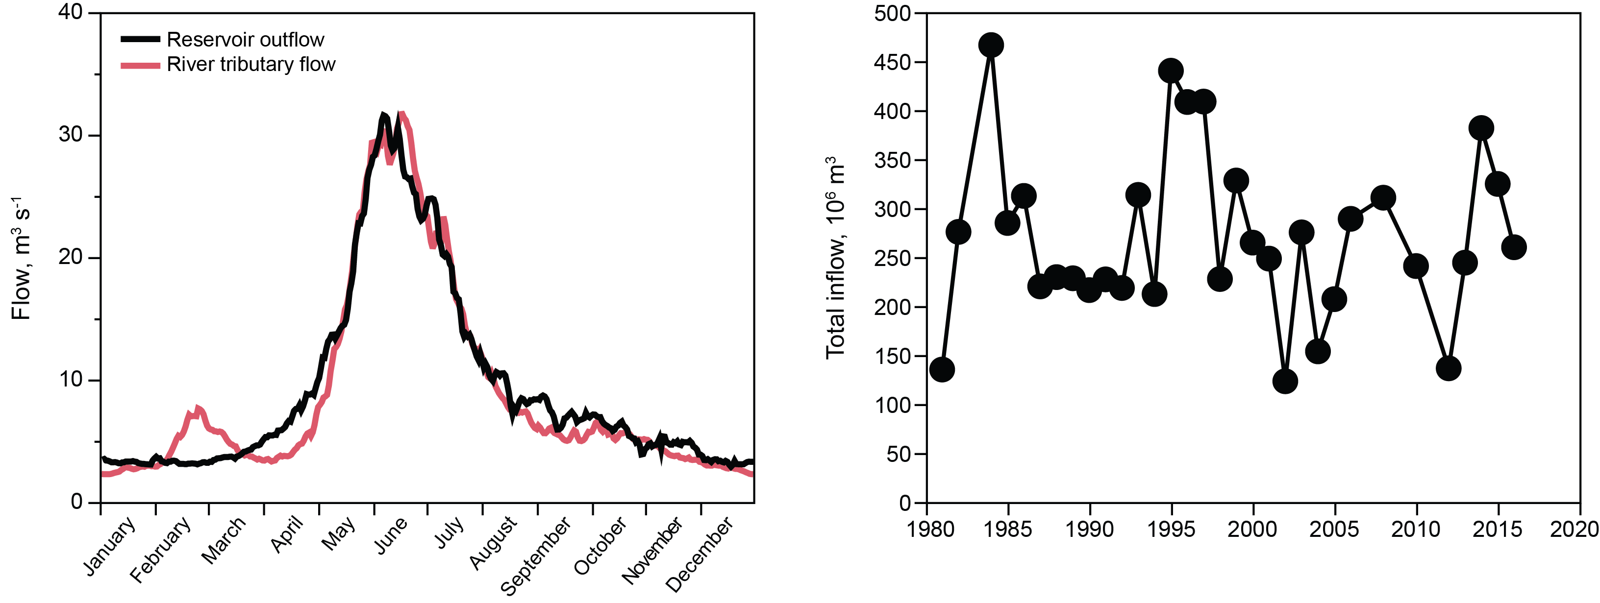
Figure 2. Left: Hydrograph of interannual mean river inflow (red line) and interannual mean reservoir outflow (2007-2016, black line). Right: Interannual variation in total inflow.

Lake Dillon had ice cover between late December and April, and showed inverse stratification under ice cover (Figure 3). Evidence of stability in layering began to appear in May, but layering was not well established until June. The mixed layer thickened monthly after July until late November, when fall mixing occurred (Figure 3).
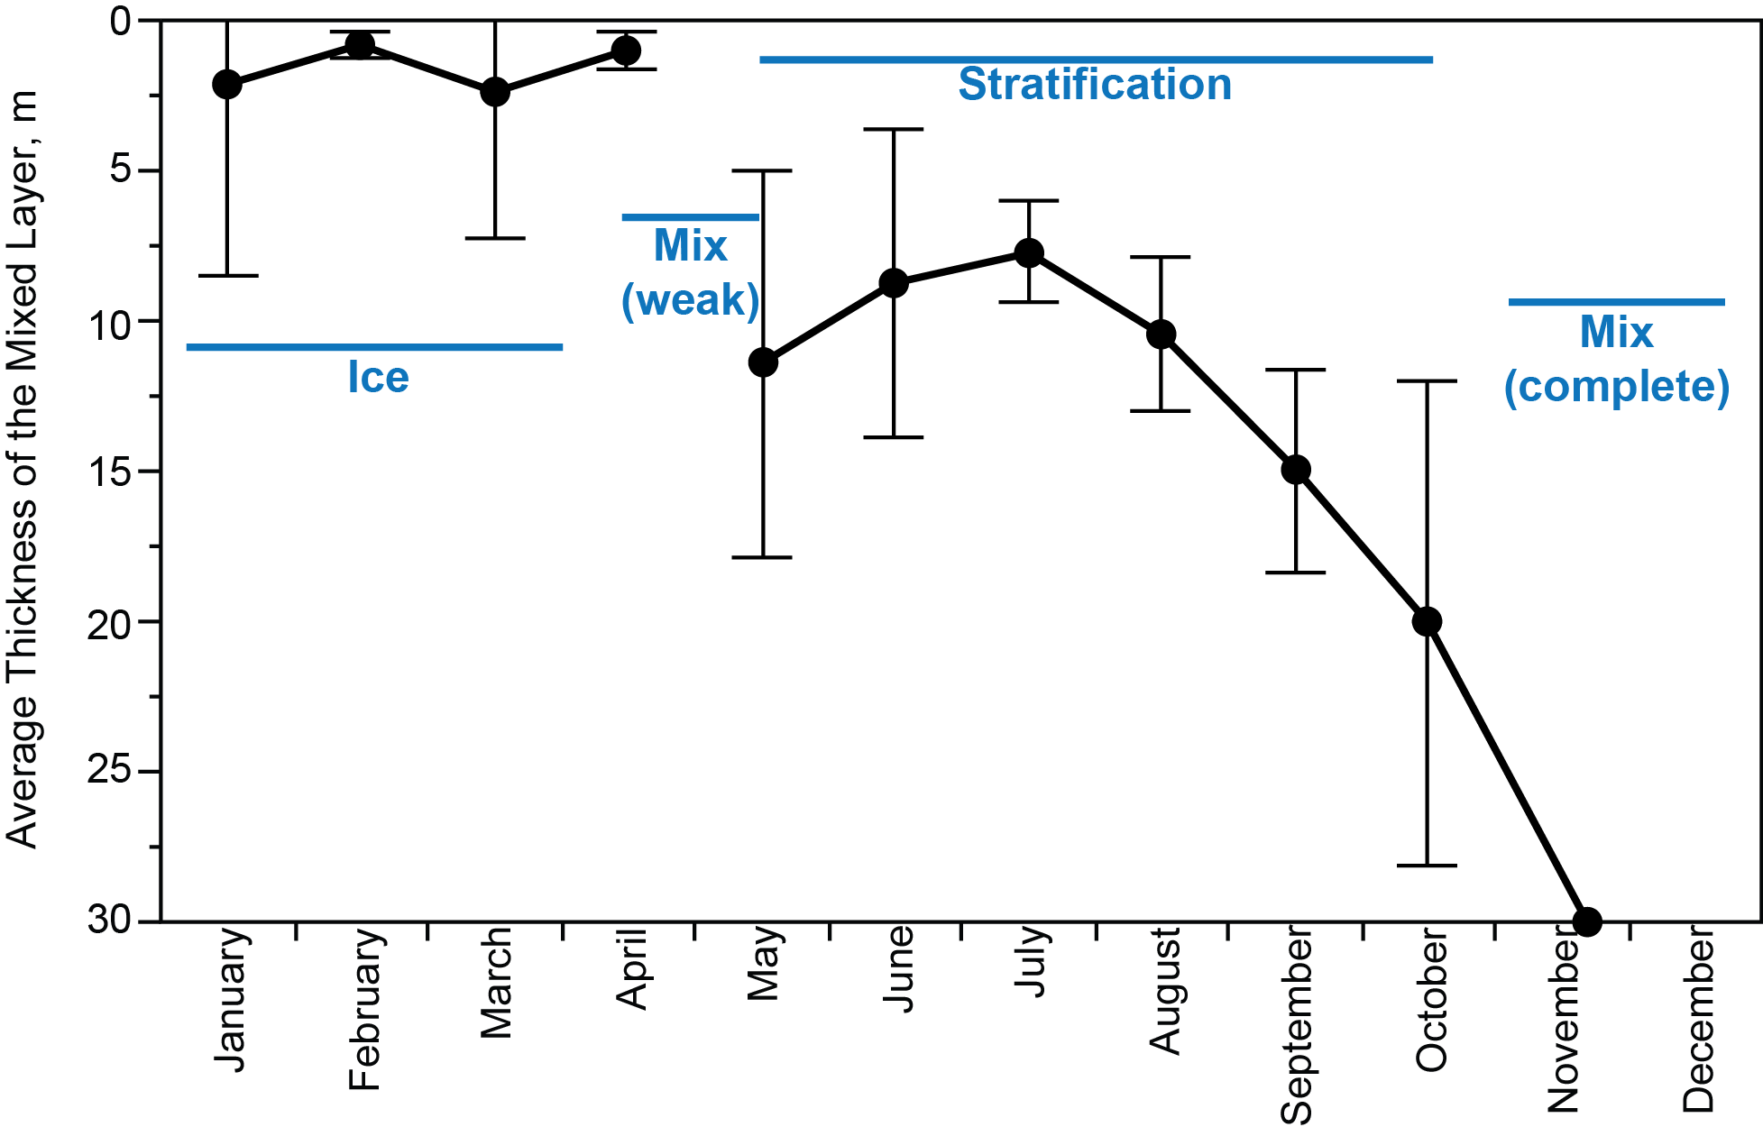
Figure 3. Monthly shift in mixed layer thickness over the stratification season (1981-2016, vertical bars show standard deviations).

The epilimnion lost water over the spillway in most years (27 of 35), but the loss rates were small relative to metabolic processes or nutrient cycling. Maximum loss as % of mixed layer volume per day for June – October over the 35 years was 3.2, 3.4, 0.9, 0.3, 0.2.
The mixed layer of the lake warmed ~2.5 °C over the 35-year study interval (Lewis et al. 2018). Deeper water warmed significantly as well, but at a lower rate. Water column stability increased by 41%, but mean mixed layer thickness did not change, nor did the mean ice free date for the lake (May 10, ±10 days). Hypolimnetic warming was sufficient to suppress eddy diffusion in deep water, but the data record shows no evidence of biogeochemical changes caused by increased stability (e.g., concentrations of dissolved oxygen near sediment, internal distribution of nutrients).

Transparency
Transparency of Lake Dillon as measured by Secchi depth (Figure 4) showed no interannual trend across the 35-year study interval. The relationship between Secchi depth and PAR extinction, K_{t} m⁻¹, was determined empirically by use of a quantum sensor to measure vertical light extinction and Secchi depth (m) concurrently over a two-year interval: K_{t} = 1.7/z_{sd}.
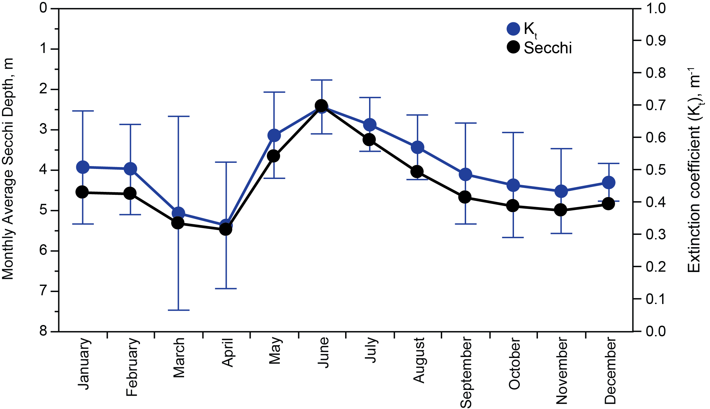
Figure 4. Monthly means and standard deviations for Secchi depth in Lake Dillon, 1981-2016, and corresponding values of total PAR extinction (K_{t}).

Components of K_{t} for PAR were estimated for all dates: pure water (K_{w}), DOC (K_{g}), algae (K_{a}), and nonliving particles (K_{p}). Because K_{w} even near the surface is small (Kirk 1994), it is possible to use a single value (0.1 m⁻¹) for the mixed layer (Lewis 2011).
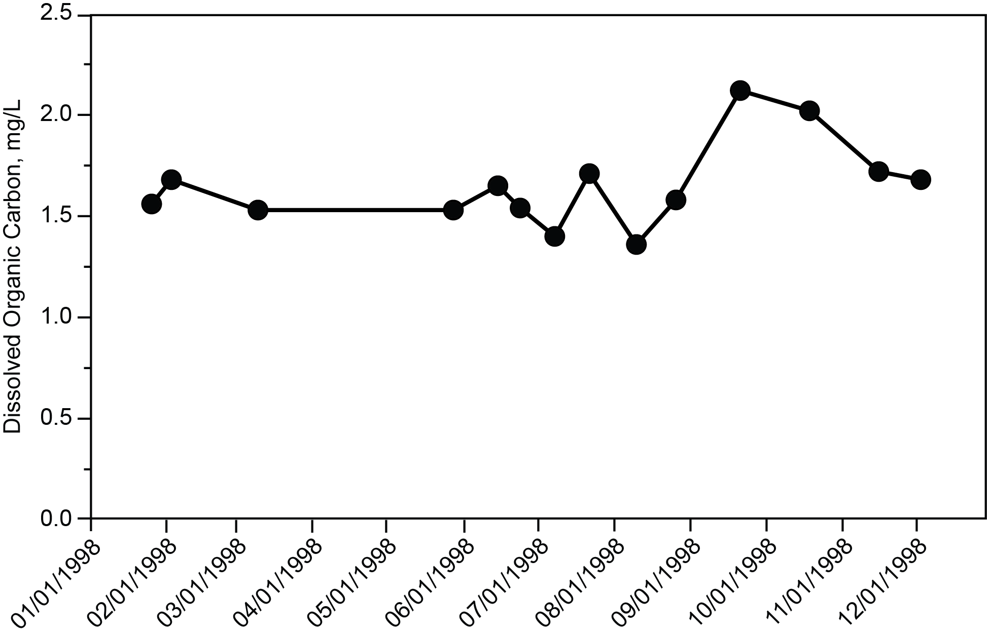
Figure 5. Concentration of dissolved organic carbon (DOC, 0-5 m) in 1998.

Dissolved organic carbon was analyzed in 1998 (Figure 5, mean 1.65 mg L⁻¹), and in 1987-1988 (Morris and Lewis 1992, means 1.71, 1.68 mg L⁻¹). All three data sets show low variance from January through August, followed by an increase of ~25% beginning in September and a decline after October (Figure 5). The effect of DOC on transparency (K_{g}) was determined in 1998 by spectroscopic scanning of filtered water samples across dates and subtraction of K_{w} across the PAR spectrum (n = 12). Despite the fall peak in concentrations of DOC, the difference in mean K_{g} for the January-August and September-December intervals was small (means: 0.123, 0.134 m⁻¹). The value of K_{g} changed with depth, but the effect of depth is opposite that of K_{w}, which reduces the need to use depth specific K_{g}. Because of its modest temporal variation and complementation with K_{w}, K_{g} is treated here as a constant, 0.13 m⁻¹.
The extinction of PAR per unit mass (μg L⁻¹) of chlorophyll was estimated as 0.015 m⁻¹ (Reynolds 2006); mean K_{a} for 0-20 m in 1998, average chlorophyll a 4 μg L⁻¹, was 0.064 m⁻¹. Change with depth in the mixed layer was small for K_{a} because absorbance of chlorophyll is distributed across the PAR spectrum.
Total suspended solids showed considerable interannual variability but followed a seasonal pattern (Figure 6). The contribution of algal biomass to total suspended solids can be estimated from the ratio of chlorophyll a to dry algal biomass (~1%, Reynolds 2006, page 37). Algal biomass was a significant component of total suspended solids only under ice cover and immediately following the melting of ice (Figure 6). Total particulate organic matter (POM) as carbon (POC) for 1987-1988 was ~0.5 mg L⁻¹, indicating POM of ~ 1 mg L⁻¹ (Morris and Lewis 1992). POC showed a seasonal pattern similar to that of TSS (Figure 2). About half of POC was algal mass; the other half of POC consisted of nonliving organic particles or DOC bonded to inorganic particles.
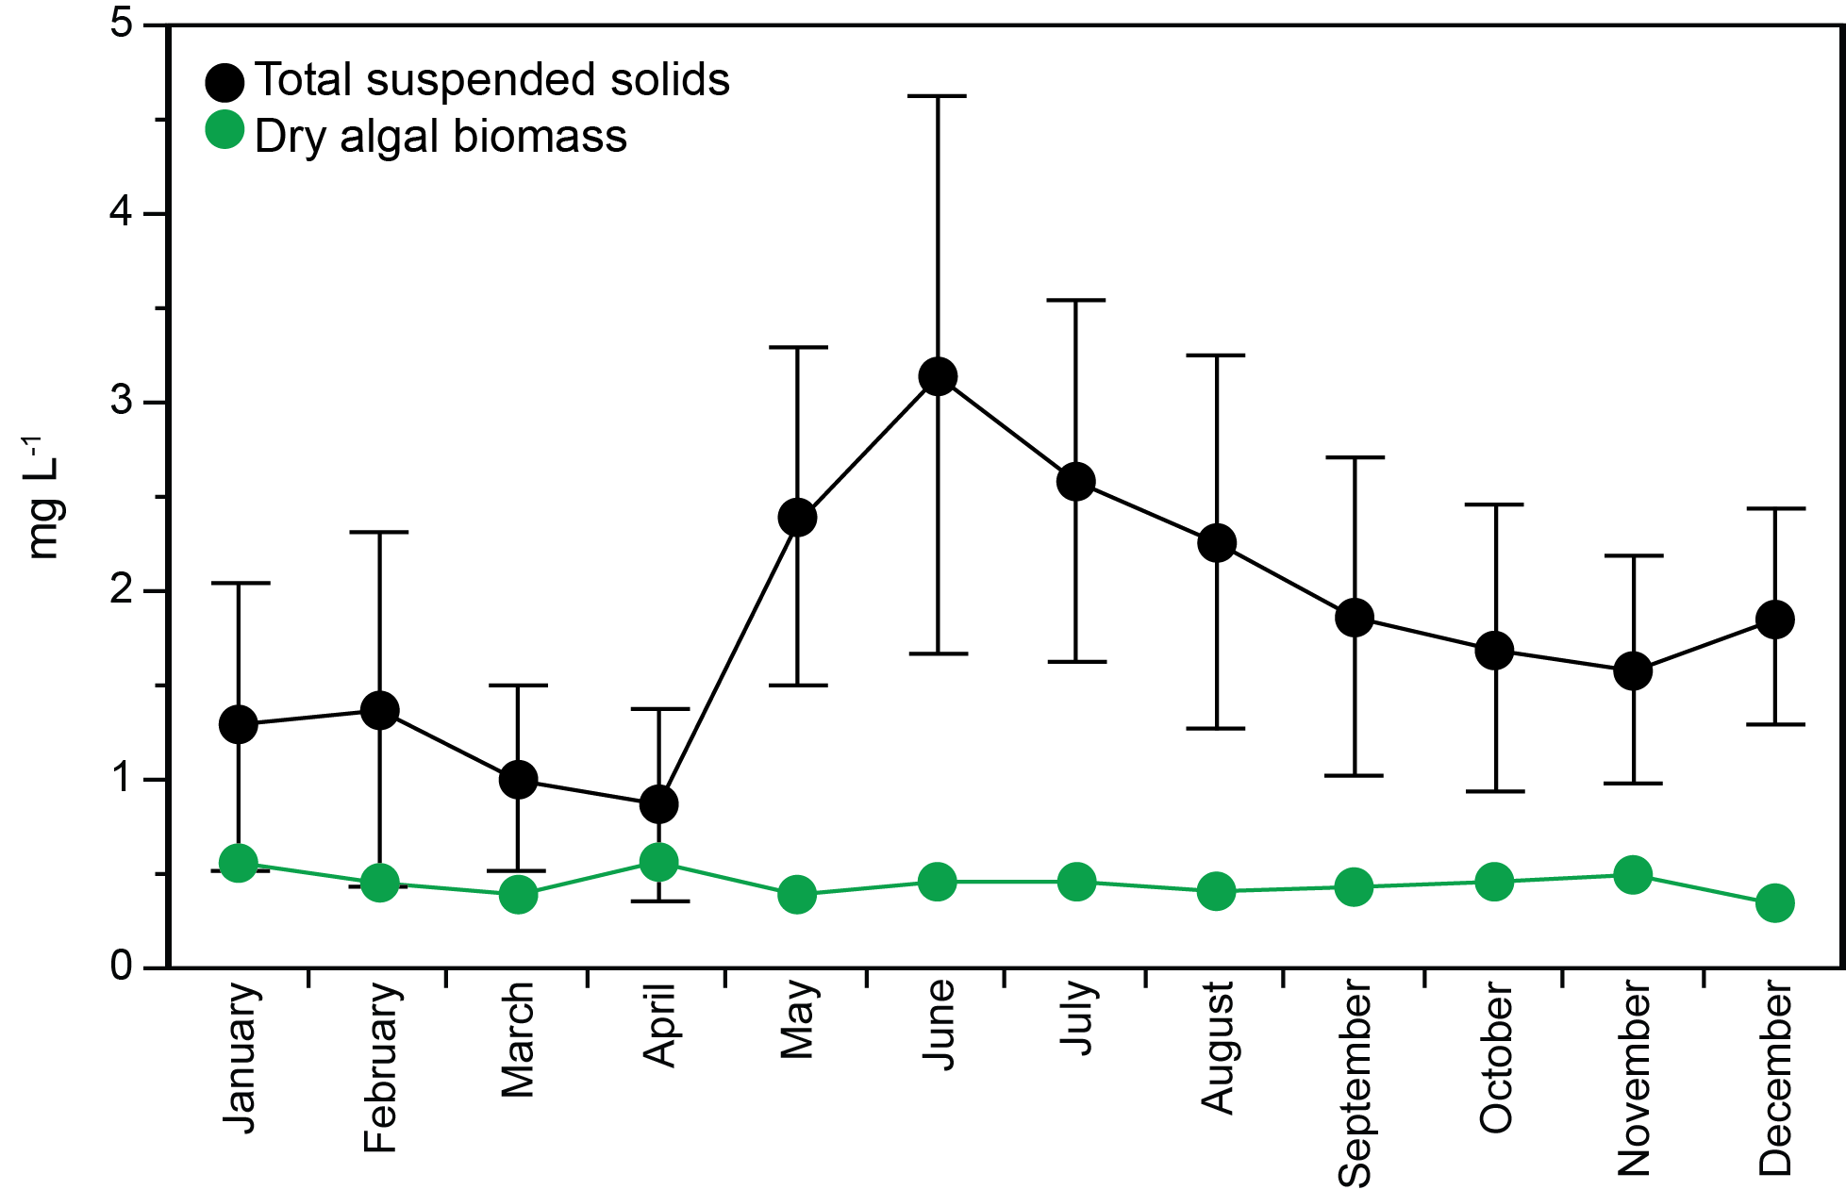
Figure 6. Amount of total suspended solids at 0-5 m in Lake Dillon, monthly for the 35-year study interval, and corresponding amounts of algal biomass in each month (bars show standard deviation).

Transport of suspended solids to the lake peaked in May and June (Figure 7). The temporal pattern for transport of solids from the watershed to the lake was offset with respect to the hydrograph in that solids were mobilized most efficiently by early phases of runoff. Suspended solids at specific depths were highest near the surface during runoff (June-August) and were more uniform before and after summer stratification (Figure 8).
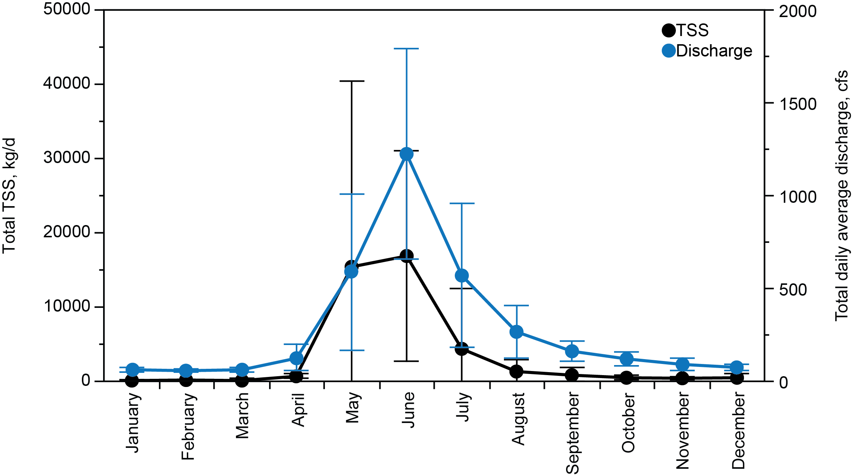
Figure 7. Temporal variation in transport of suspended solids to Lake Dillon shown as combined mass for the three tributary rivers as monthly averages, 1981-2016, and monthly mean river discharge.
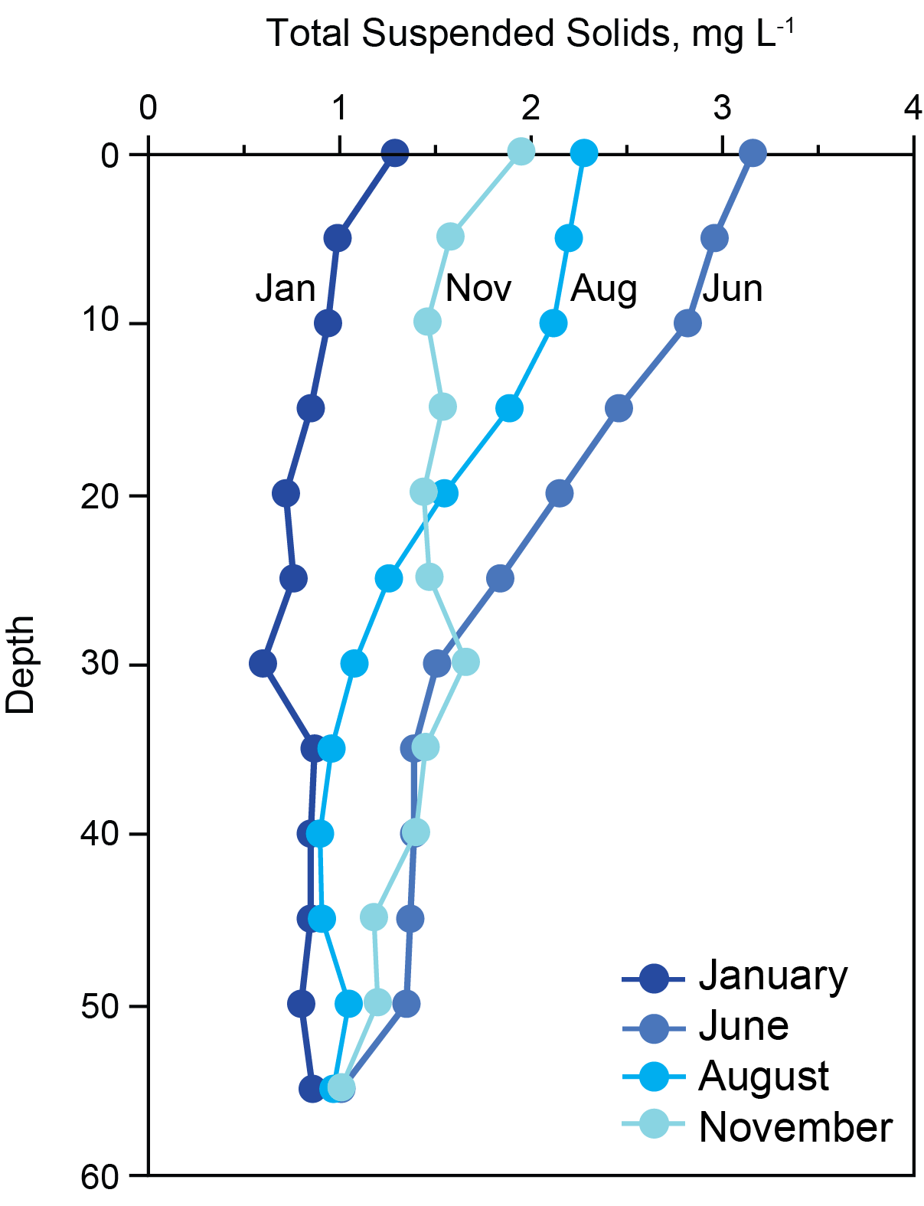

Figure 8. Mean vertical distribution of TSS over 35 years for specific months.
The mean sedimentation loss rate of solids for 0-5 m was 0.01 mg L⁻¹ per day from June to September. The sedimentation process removed approximately half of suspended solids by September. The other half, which presumably consisted of solids of smaller grain size, was lost from the water column more gradually during the winter months, leaving nonalgal suspended solids in the mixed layer equivalent to ~30% of the maximum that was present in June.
The value of K_{p} was computed as a residual from the measured value of K_{t} mean (0.45 m⁻¹, Figure 6) and the empirically based estimates for K_{w}, K_{g}, and K_{a} as described above. K_{p} had strong seasonal variation, whereas the other components of K_{t} did not. Proportionate contributions to K_{t} are shown in Table 1.
Component |  | Value, m⁻¹ | SD
K_{w} | Water | 0.10 | 0*
K_{g} | DOM | 0.13 | 0*
K_{a} | Algal biomass | 0.066 | 0.035
K_{p} | Nonliving particles | 0.24 | 0.19
K_{t} | Total | 0.54 | 0.20
*Low variance, treated as a constant.

Table 1. Mean proportionate contributions to K_{t} in Lake Dillon (mean for ice free season, chlorophyll 4 μg/L).

Phosphorus
The record for phosphorus concentrations consists of three phases. Phase 1, 1981-1984, includes 1981-1982, prior to control of P loading for the lake and 1983-1984, when tertiary removal of P from municipal wastewater treatment plants occurred. In 1985-1995 (Phase 2), control of P loading focused on soil disturbance and urban runoff. In phase 3 (1996-2016), reduction of P load from failing septic systems was implemented gradually through installation of sewer lines that took domestic wastewater to tertiary treatment plants.
There was no statistically detectable trend in total P over the 31 years after tertiary treatment, 1985-2016 (mean 2840 kg y⁻¹). The right panel of Figure 9 shows total load adjusted for variations in hydrology (mean 2880 kg y⁻¹). The adjustment was accomplished through use of a watershed model that included empirically based, calibrated relationships between phosphorus yield and runoff for specific source categories, including background, housing served by septic systems, housing served by sewer, ski resorts, and others (Lewis et al. 1984). Modeling was used to adjust all loads to a common hydrologic year; 1982 was taken as the reference year because the phosphorus control regulation was based on phosphorus loads that occurred in 1982. Use of the model reduces variance related to hydrology among years, which allows more accurate assessment of compliance with the control regulation. Years 1984 and 1995 showed anomalously high loads because of flooding; the hydrologic correction brought these years nearer to the range of loads for other years. The model magnified the observed loading in 2013, when recovery from drought increased the particulate P transport caused by runoff. The decline between 1981-1982 included the documented decline in wastewater treatment P release (700 kg y⁻¹), which is clarified when effects of hydrologic variation are minimized (right panel, Figure 9), but the effects of subsequent measures for additional gradual reduction of total P load are not evident in either the raw data or the hydrologically adjusted data.
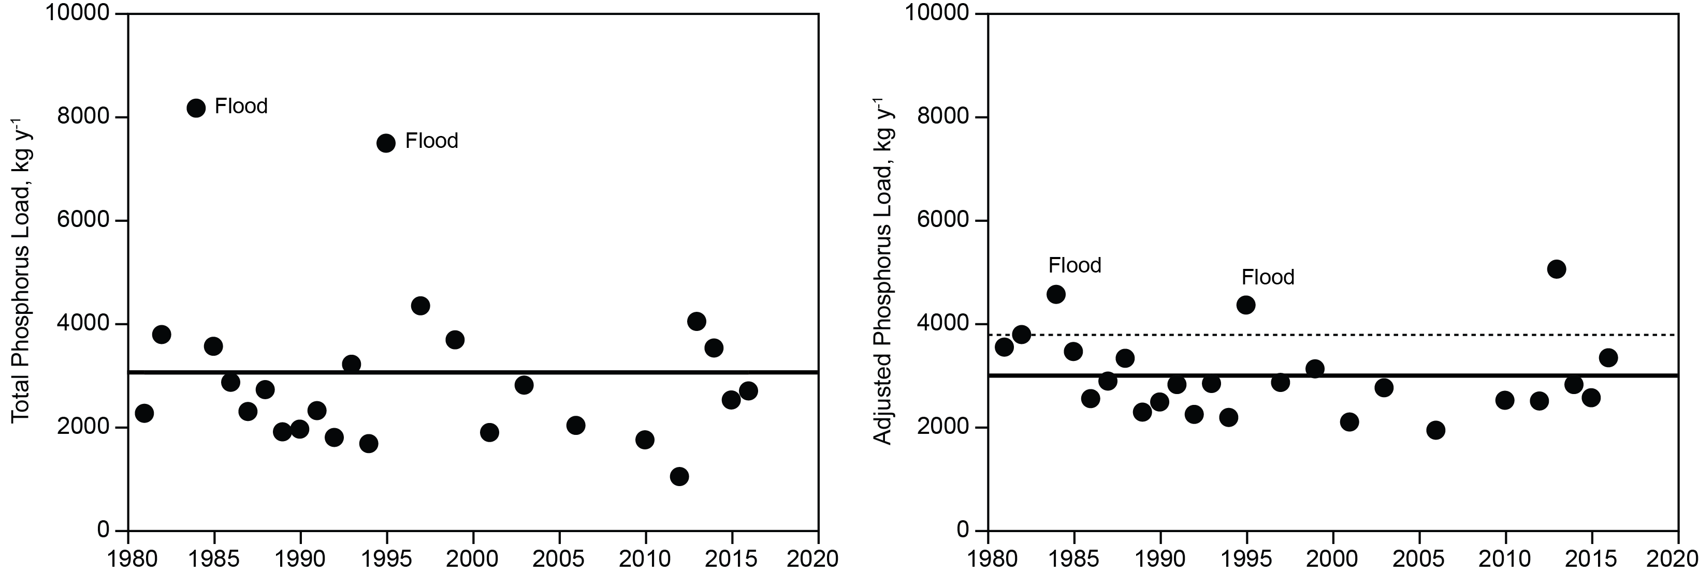
Figure 9. Total P load for Lake Dillon from all sources, 1981-2016. Left: P load calculated from measurements of P sources. Right: P load adjusted to 1982 hydrologic conditions. The solid line shows the mean; the dashed line is the 1982 benchmark for the control regulation (3778 kg y⁻¹).

Figure 10 shows the effect of tertiary treatment in controlling phosphorus release from municipal treatment plants. The effect of tertiary treatment was strongest in 1981 and 1982 and created a reduction in phosphorus release of approximately 700 kg y⁻¹. Figure 10, right panel (expanded scale for 1986-2016), shows that additional improvements in efficiency of tertiary treatment after 1985 accounted for further reduction of ~30 kg y⁻¹ (p < 0.01, r² = 0.36) in total P.
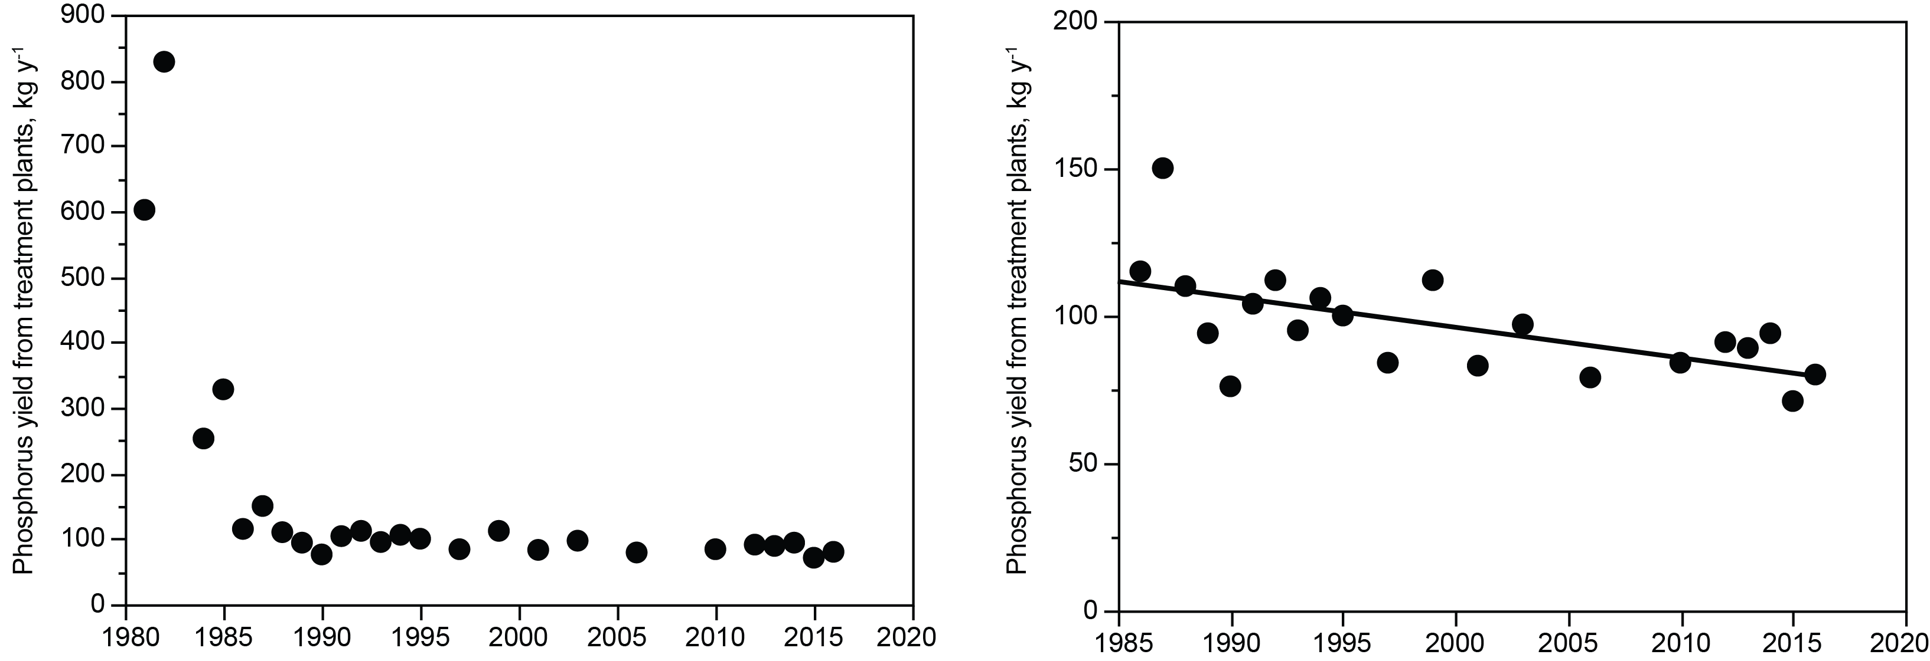
Figure 10. Left: Total P discharge from wastewater treatment facilities, 1981-2016 showing effect of tertiary treatment (after 1985). Right: Total P discharge after implementation of tertiary treatment (1986-2016) showing refinement of tertiary technology. A data point for 2008 is omitted because of anomalous P releases caused by a failure of one facility to maintain fully effective treatment over part of a year.

There was no detectable secular trend in loading of total P during phase 2 in response to reduction of soil disturbance and urban runoff. During phase 3, the effect of septic system removal, as estimated empirically through watershed mass balance studies (Lewis et al. 1984), was ~250 g P y⁻¹ per septic system (watershed total ~ 100 kg y⁻¹). The reduction of load from septic systems likely occurred gradually beyond the deactivation date of the systems because of terrestrial migration of septic P that was distributed gradually to streams. Also, reduction of P load from septic systems may have been offset with other nonpoint sources that increased gradually with population growth. Overall, the phosphorus control measures between 1981 and 2016 were successful in preventing increase in phosphorus loading associated with growth in population (50% for full time residents, 100% for seasonal residents, 1981-2016).
For 1981-2016, total phosphorus in the mixed layer (0-5 m) of Lake Dillon averaged 6.6 ± 1.0 μg L⁻¹ (all months, Figure 11). Mean concentrations of soluble reactive phosphorus (SRP) and total dissolved phosphorus (TDP) between 1981–2016 were 0.7 ± 0.2 and 2.8 ± 0.7 μg L⁻¹. A severe drought that drastically reduced the lake volume in 2002-2003 produced notable peaks in TP and particulate P, probably because of lacustrine sediment movement caused by wind over the shallow water of the lake at drawdown. Total P and P fractions showed no secular trend and no statistical relationship to total annual water inflow or hydraulic residence time for 1981-2016 (Figure 11).
Mean monthly concentrations of total P in the upper water column of Lake Dillon showed suppression in March and April, probably because of the addition of lake ice melt water to the upper water column at that time, and a peak in May-July during spring runoff. Variations in total P across months were weakly reflected or not reflected in TDP or SRP, i.e., variation in total P was caused mostly by particulate P.
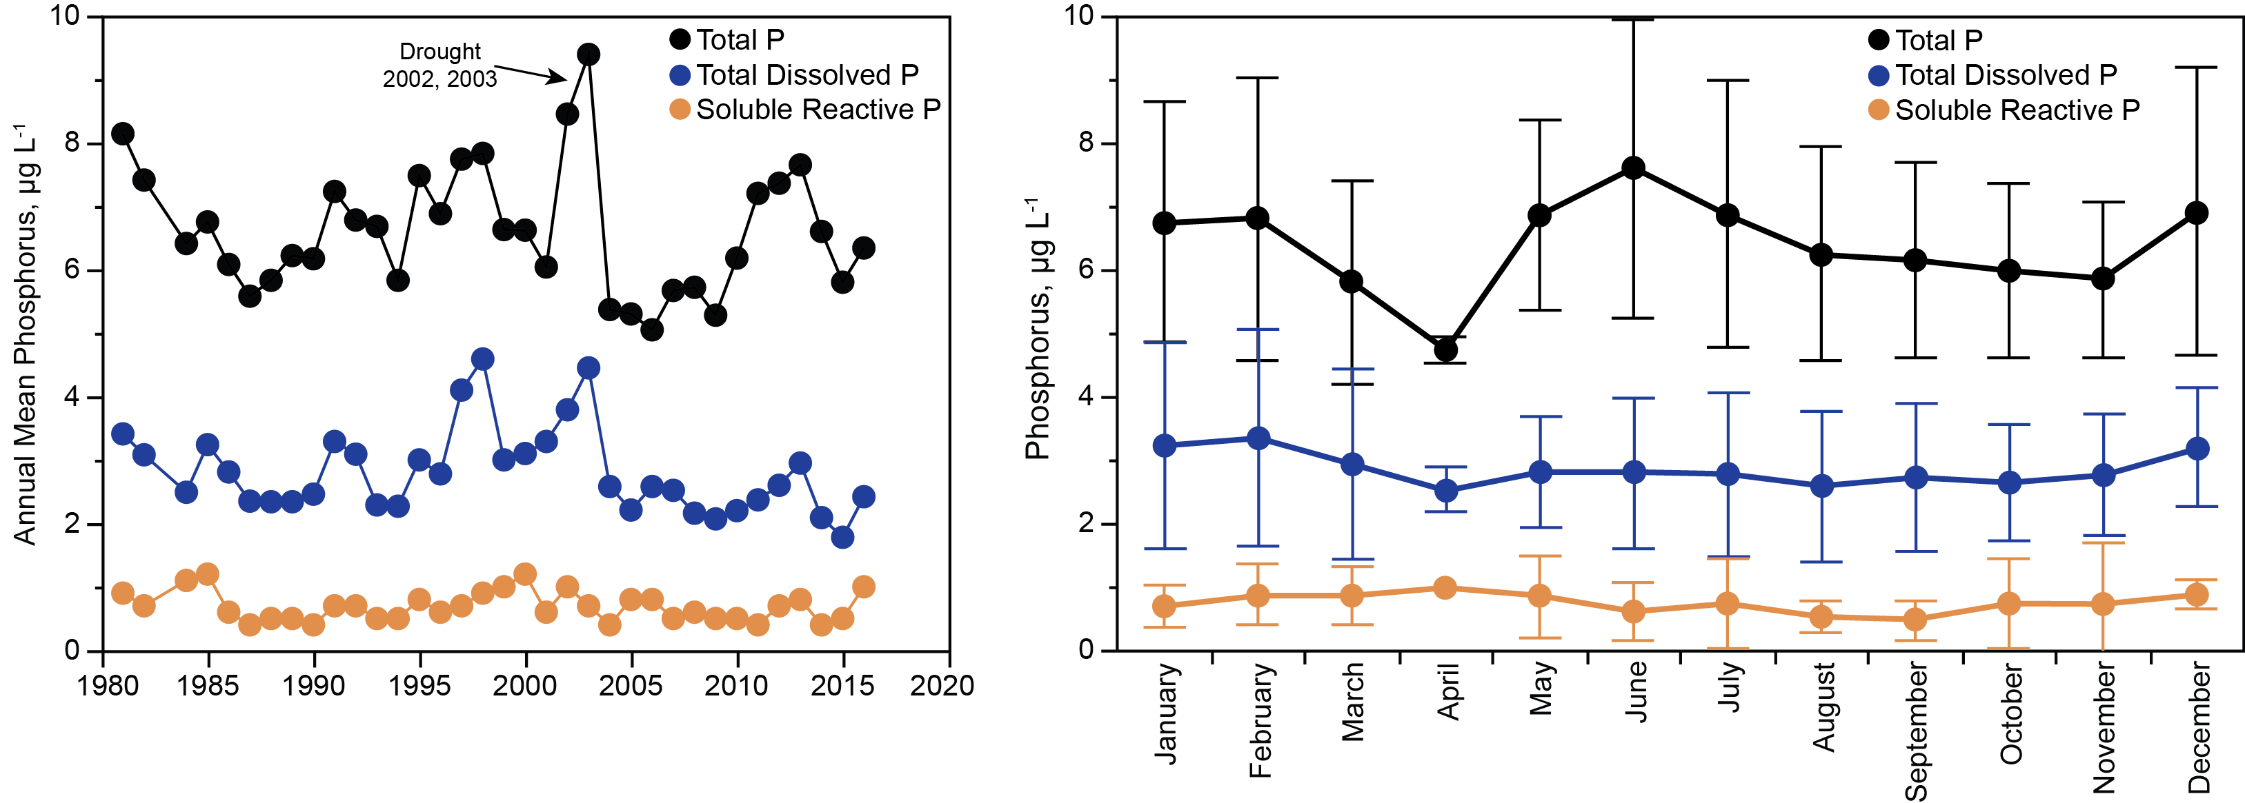
Figure 11. Left: Total P, TDP, and SRP for Lake Dillon, 0-5 m, as annual means, 1981-1985, and 1986-2016 (after tertiary treatment of P in wastewater). Right: concentrations of total P and P fractions at 0-5 m in Lake Dillon as monthly means and standard deviations for 1986-2016.

Vertical distributions of TDP and SRP were nearly uniform, but particulate P showed ~30% higher concentrations in the upper 10 m than at greater depths (Figure 12). The vertical pattern of particulate P was not caused by algal biomass, which was a small component of particulate P in most months, but rather by non-algal particles. Because the lowest water column concentrations of dissolved oxygen were above 4 mg/L, there was no redox related acceleration of P release from deepwater sediments (Figure 12). Studies of a nearby lake show that P release from sediments under oxic conditions are low in montane lakes of the study region (Anthony and Lewis 2012).
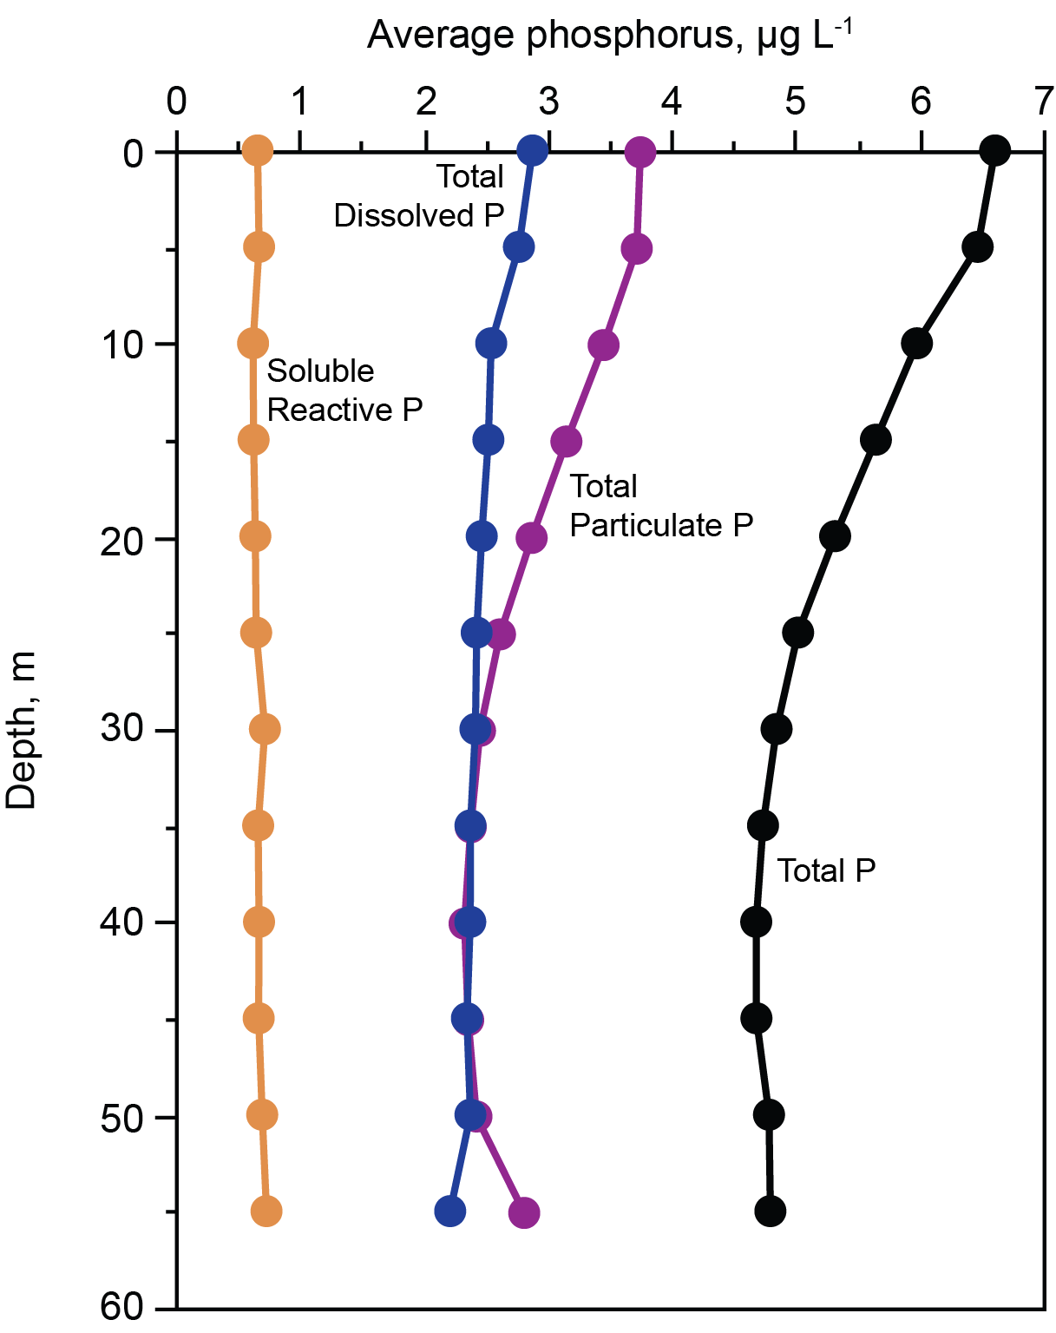
Figure 12. Average concentrations of phosphorus fractions across all depths, 1986-2016.

Nitrogen
Total nitrogen and dissolved nitrogen were analyzed only for 1981-1982 and 2011-2016 (Figure 13); nitrate was analyzed for all sampling dates (Figures 14, 15). Concentrations of ammonia were measured less frequently and, near the surface, were low (typically <5 μg L⁻¹), implicating nitrate as the main nitrogen supply for phytoplankton. Because nitrogen was not included in the water quality regulations, nitrate was subject to influence by watershed development, whereas phosphorus, which was regulated, was not.
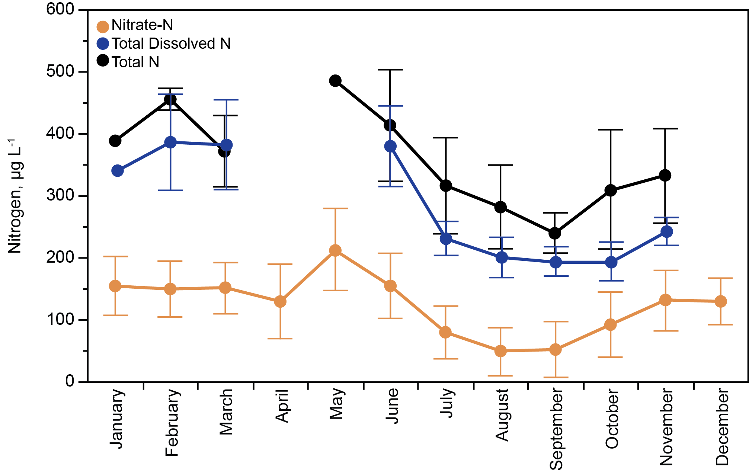
Figure 13. Concentrations of total N (2011-2016), total dissolved N (2014-2016), and nitrate (1981-2016) in Lake Dillon (0-5 m), means and standard deviations.

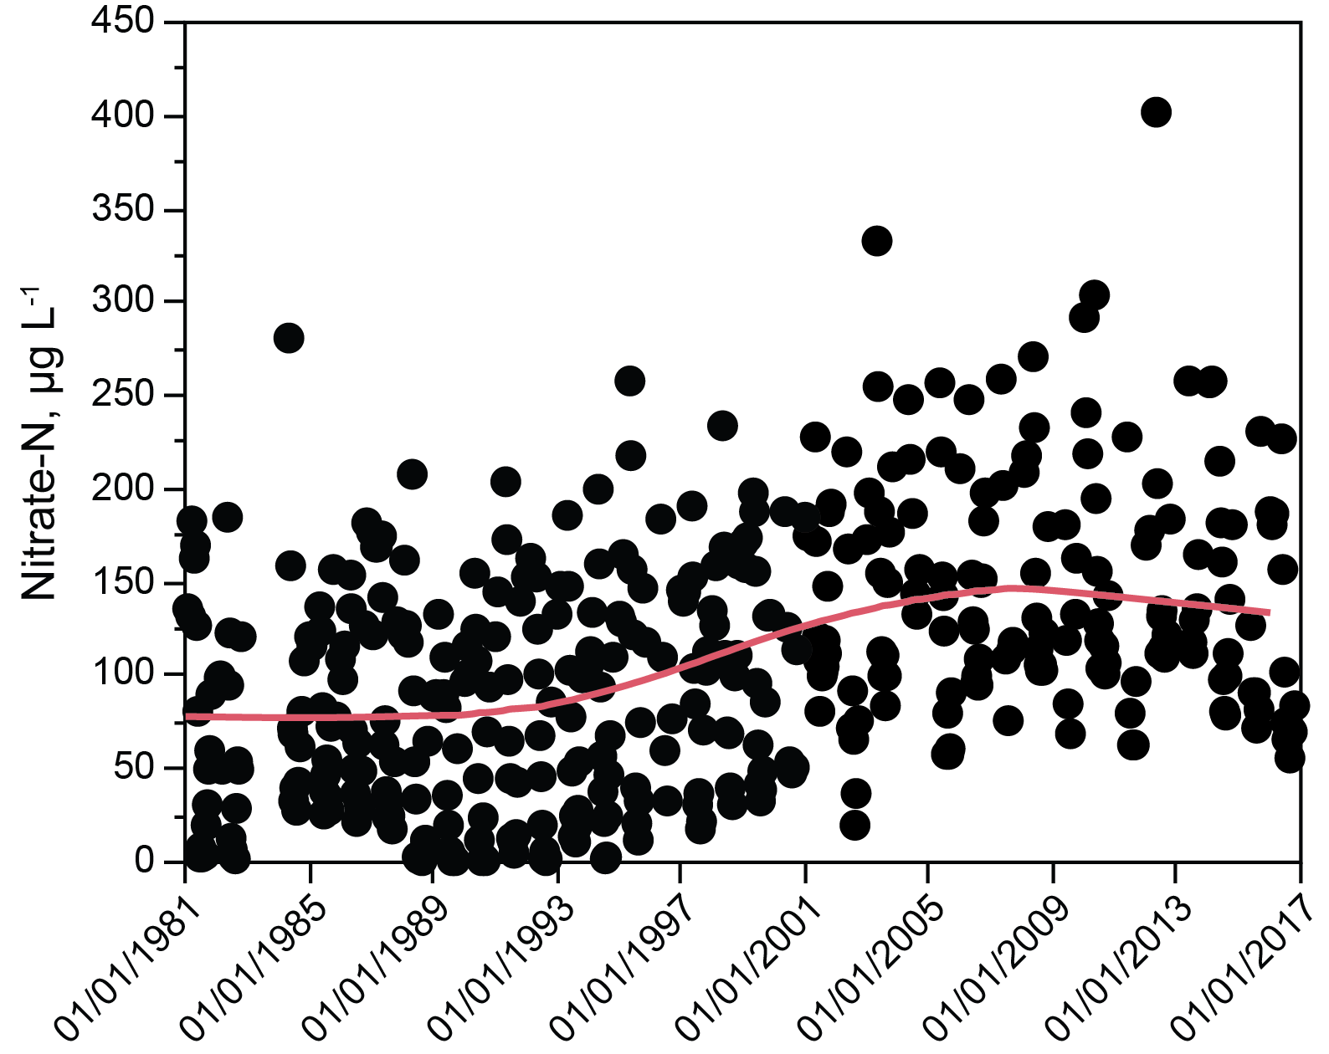
Figure 14. Temporal trend in nitrate concentrations for Lake Dillon (0-5 m, all dates), 1981-2016. The red line shows a LOWESS polynomial fit for the data.

Mean nitrate concentrations in the upper water column of Lake Dillon increased threefold between 1981 and 2009, in parallel with watershed development (Figure 14, increase from ~50 to 160 μg L⁻¹), reflecting mainly the effects of wastewater treatment plants and septic systems (Kaushal et al. 2006). After 2009, the trend reversed (Figure 14, decrease from ~160 to 120 μg L⁻¹), but with a lag of a few years that likely was caused by the large water volume of the lake. Decline in nitrate loading was greatest for the Blue River. The Snake River showed a similar but weaker declining trend, and Tenmile Creek did not show a trend. Denitrification of Blue River effluent appears to have been at least one cause of decreasing nitrate concentrations in Lake Dillon after 2009.
Annual minimum concentrations for nitrate in the mixed layer of the lake prior to 1997 often were near zero (<5 μg L⁻¹, Figure 14). After 1997, there was a continuous increase in the annual minimum nitrate concentrations culminating in minimum concentrations that were near 70 μg L⁻¹. Nitrate concentrations increased by similar amounts throughout the water column, but the mean concentrations of nitrate were higher at intermediate and great depths than near the surface.
As the mixed layer thickened in the fall, its nitrate concentrations increased. Nitrate depletion near the surface coincided with favorable growing conditions for phytoplankton. During the stratification season, but prior to seasonal thickening of the mixed layer, it is possible to estimate the rate of algal nitrate uptake from the changes in concentrations of nitrate in the mixed layer. Because of secular change in concentrations across years, the data must be analyzed over several time intervals, which do not differ statistically in slope but have different intercepts (Figure 15). The slope corresponds to a mean cumulative loss of 190 μg L⁻¹ of nitrate-N for the 2.5 month interval or, based on the Redfield ratio (106 C:16 N molar), 140 mg m⁻² d⁻¹ of photosynthetic carbon fixation in the mixed layer (0-10 m). Mean measured net primary production for 1987-1988, May-July was 280 mg C m⁻² d⁻¹, indicating that algal growth fully explains loss of nitrate from the mixed layer, and that approximately half of primary production was supported by N cycling in the mixed layer, i.e., mineralization of organic N originating mainly from phytoplankton mortality.
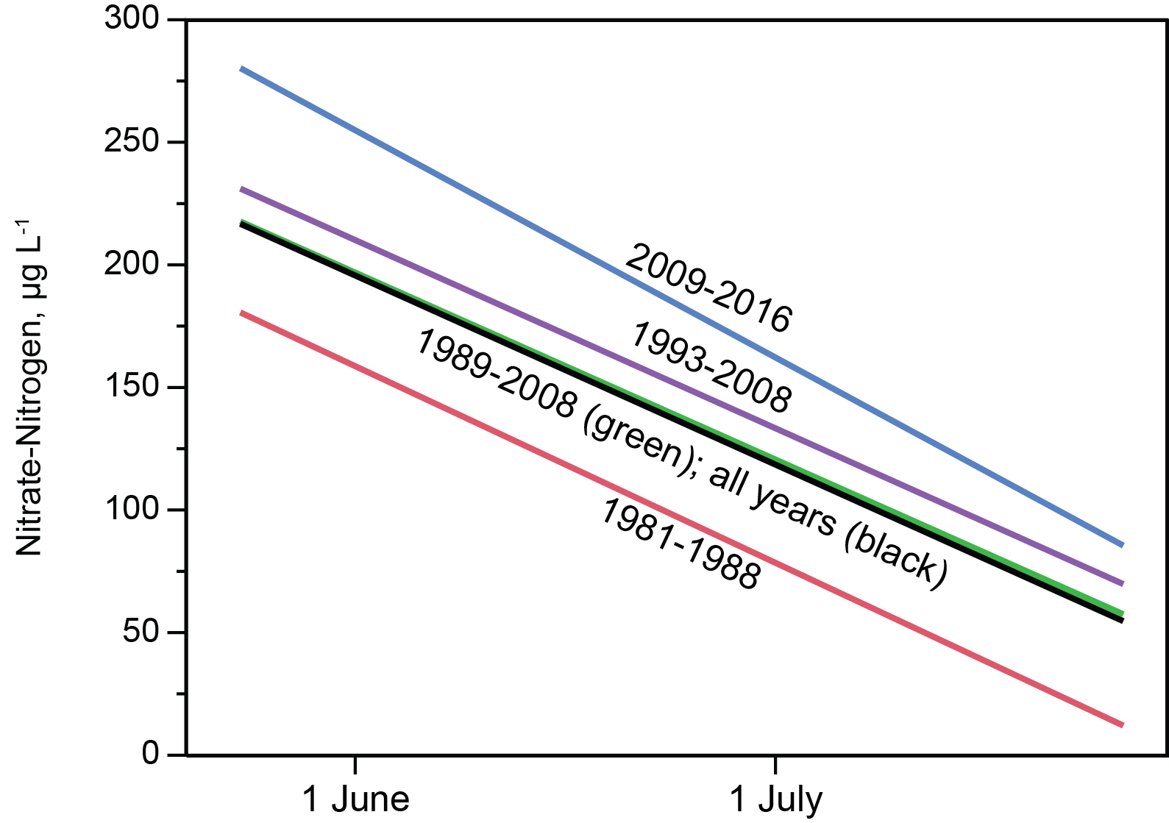
Figure 15. Concentrations of nitrate for the mixed layer, mid May through July, for all years and for clusters of years separated by increasing concentrations of nitrate in Lake Dillon.

Algal Biomass (Chlorophyll)
For 1981-1982, prior to tertiary treatment of P for wastewater, mean chlorophyll concentrations in the mixed layer (8.1 ± 3.7) were significantly greater than mean concentrations for 1984-2016 (4.1 ± 1.9), after tertiary treatment for P had been implemented (Figure 16). Following the abrupt change in chlorophyll caused by tertiary treatment in 1981-1982, the interval between 1984 and 2016 showed a slow but significant downward trend in annual mean and maximum concentrations of chlorophyll (Figure 16). The trend line for annual means corresponds to 5.1 μg L⁻¹ in 1984 and 2.9 μg L⁻¹ in 2016, i.e., a change of 43% over 32 years. A LOESS regression analysis shows that the overall pattern is composed of two parts: 1985-1995 (P removal phase 2) showed no slope, and 1996-2016 (phase 3) showed a significant downward slope (Figure 11). Chlorophyll a at 0-5 m showed no significant statistical relationship to hydraulic residence time or total annual water inflow to Lake Dillon for 1984-2016.
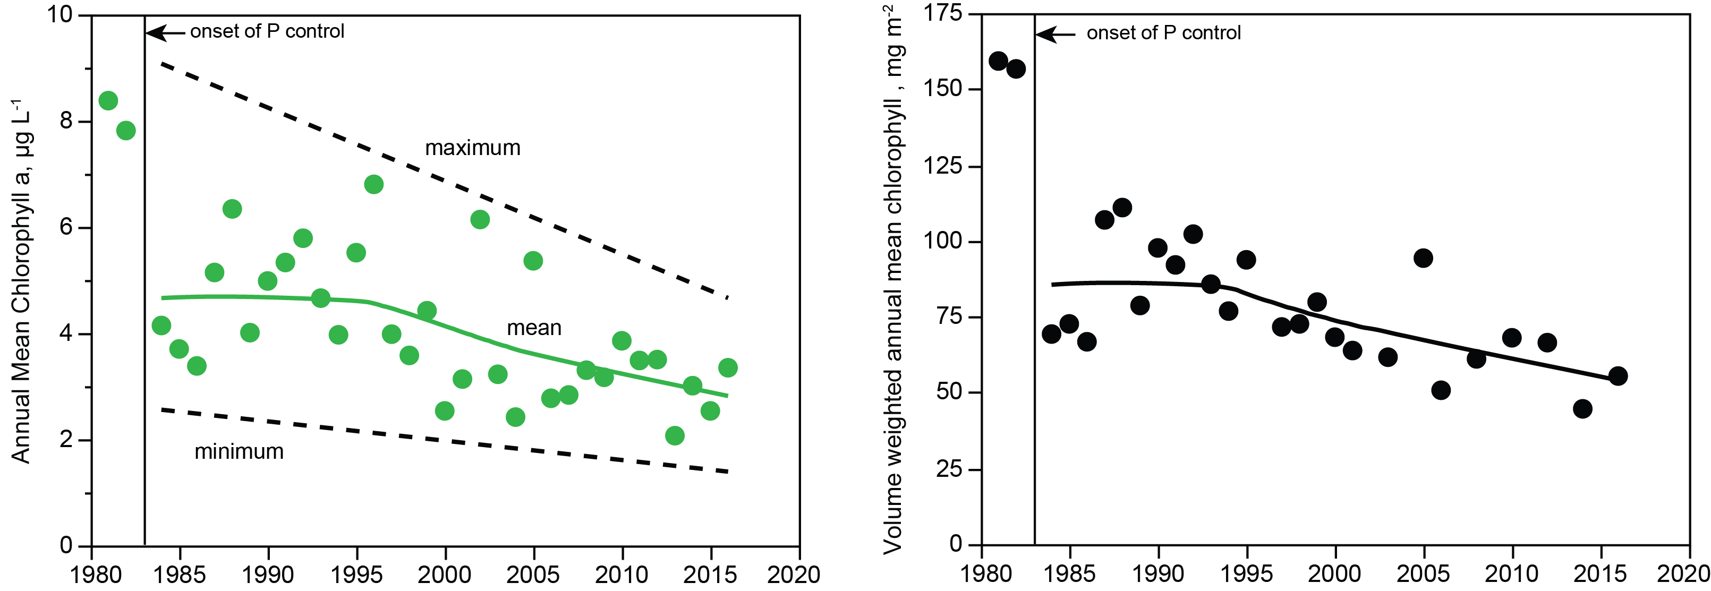
Figure 16. Left: concentrations of chlorophyll a in Lake Dillon, 0-5 m, 1981-1982 and 1984-2016. Points show annual means; the solid line shows no trend for 1985-1995, and a significant decline thereafter (r² = 0.23) mean chlorophyll (r² = 0.28, p < 0.01), and the dashed lines show the annual maximum and minimum. The green line is a LOWESS polynomial regression (alpha = 0.75). Right: annual mean chlorophyll per unit area of Lake Dillon, 1984-2016. The trend line is a LOWESS polynomial regression (alpha = 0.75). In year 2002, chlorophyll per unit area was greatly affected by drawdown of reservoir volume due to drought, and is excluded from the regression (r² = 0.37, p < 0.01).

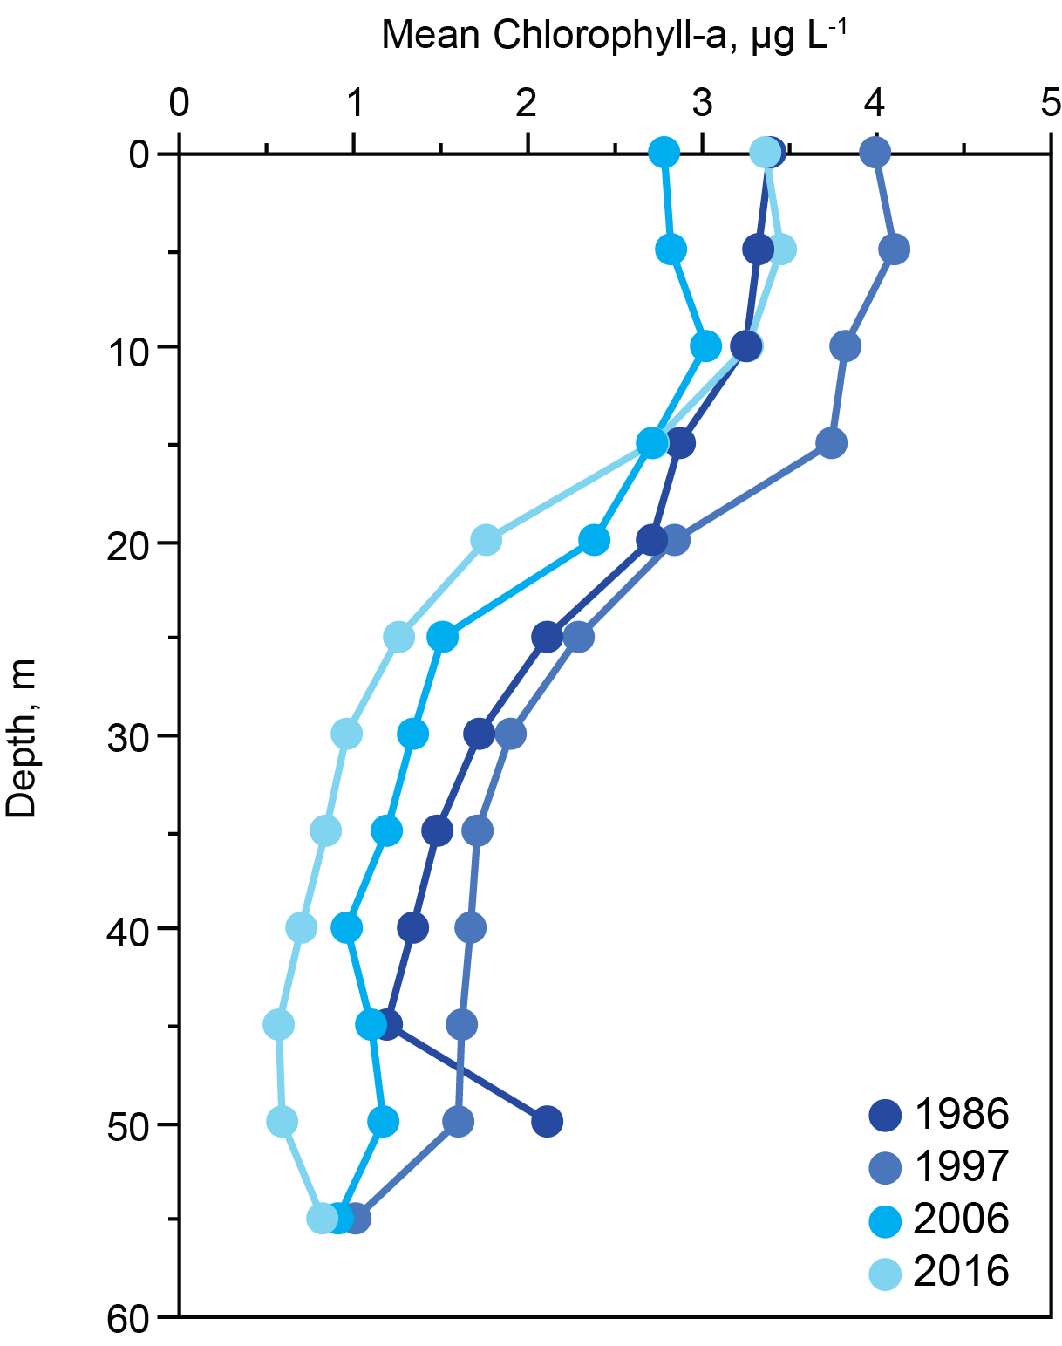
Figure 17. Mean annual chlorophyll with depth for specific years at decadal intervals.

Across months at 0-5 m, January showed the highest mean chlorophyll concentration (Figure 17). March showed the lowest concentration and the establishment of stratification (May) was accompanied by an increase in mean chlorophyll concentrations culminating in mean concentrations that were nearly constant between June and November at ~4 μg L⁻¹. Interannual variance for all months was considerable and probably is explained by nonsecular variance in meteorological conditions (cf. Finger et al. 2013).
Chlorophyll concentrations below the euphotic zone averaged ~30% of chlorophyll in the euphotic zone (Figure 17), and showed high stability except in November – December, when deep mixing homogenized the concentrations vertically.
Chlorophyll concentration per unit volume in the mixed layer (Figure 18) showed no interannual trend in abundance per unit volume of phytoplankton over the stratification season (May – mid-November). Chlorophyll per unit area in the mixed layer (Figure 19), however, showed a significant increase in phytoplankton biomass per unit area beginning in August and ending in November at the time of full mixing; growth corresponded to thickening of the mixed layer toward the end of the stratification interval as nutrients below the thermocline entered the mixed layer. Although the phytoplankton biomass per unit volume in the mixed layer was essentially constant, the amount of mass per unit area almost doubled as the thickness of the mixed layer increased.
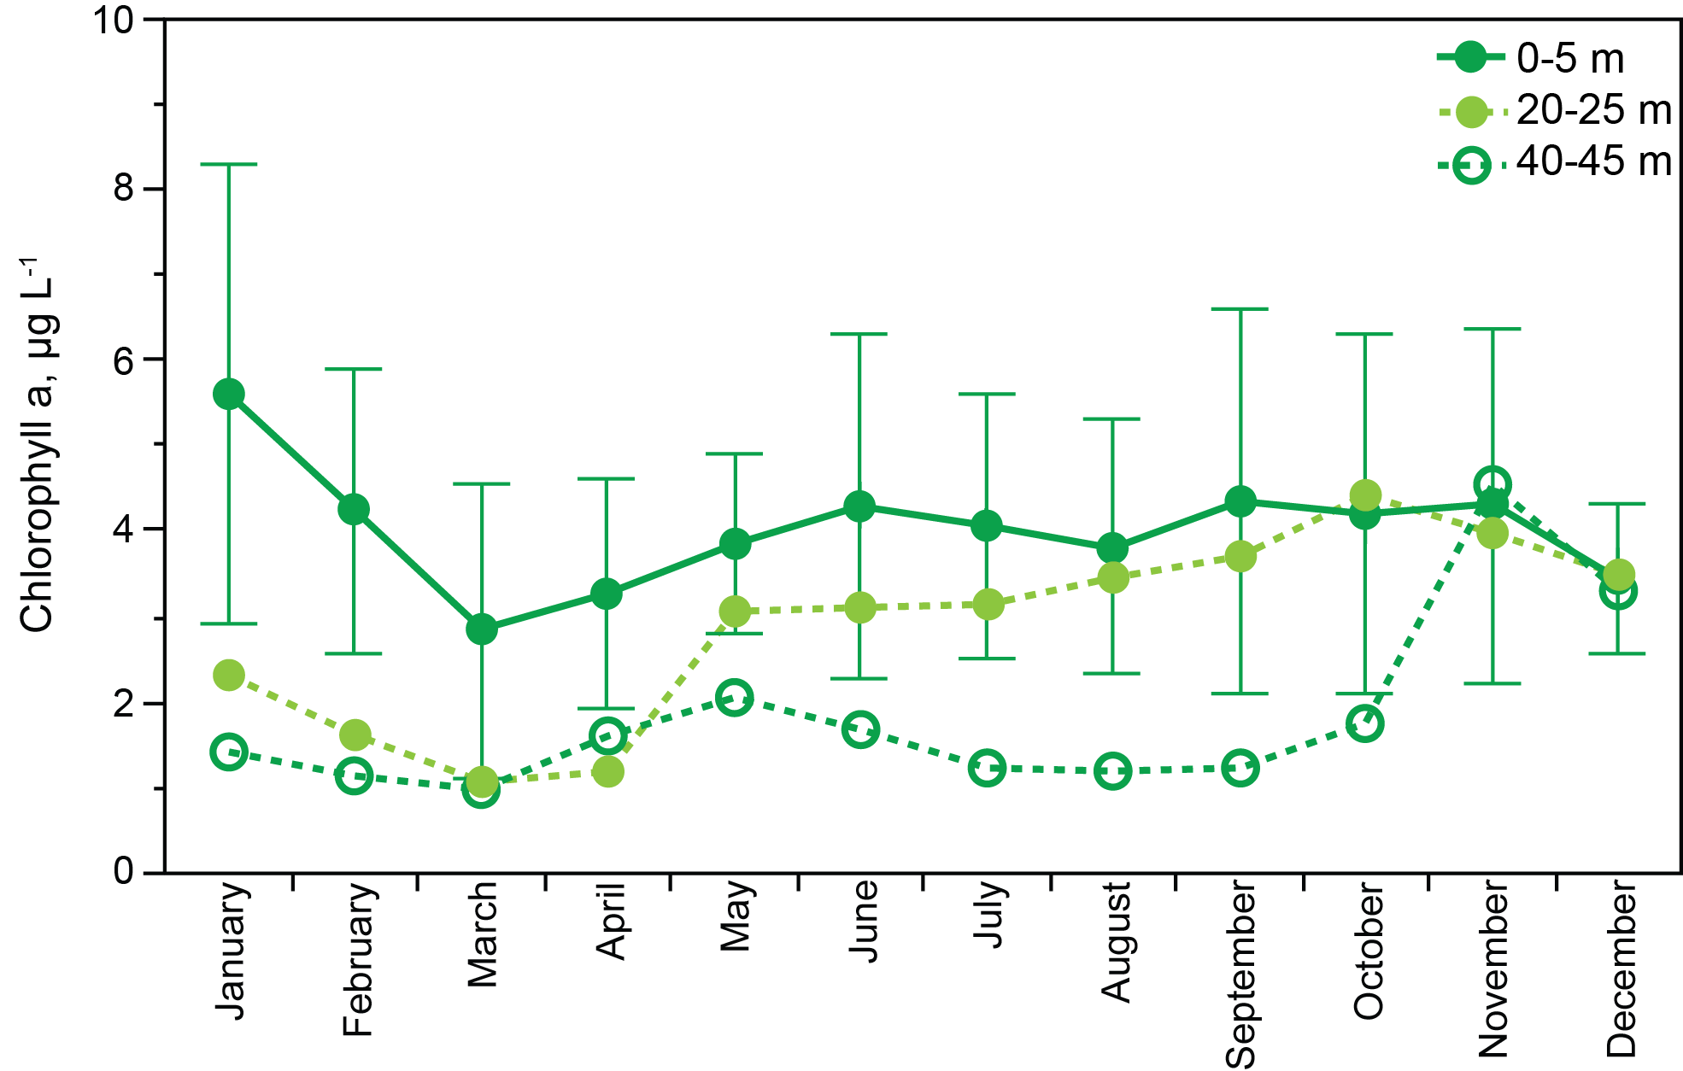
Figure 18. Abundance of chlorophyll a (monthly means with standard deviations, 1984-2016) at 0-5 m, 20-25 m, 40-45 m.
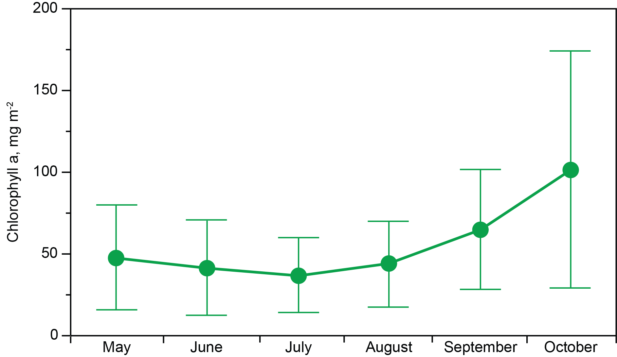
Figure 19. Chlorophyll per unit area over the mixed layer, monthly mean and standard deviations, 1984-2016.

Figure 20 shows phytoplankton biomass per unit area for the entire water column over all months. November was the month of maximum biomass per unit area; high biomass carried into December with no change but then showed, despite a notable increase in biomass just under the ice in January, a loss of approximately 50% of water column biomass from December-January; losses under ice cover during January through March brought down abundances to approximately 35 mg m⁻², or about a third of the maximum that was observed during November and December. Net mortality of phytoplankton under ice cover was approximately 0.67 mg m⁻² d⁻¹ chlorophyll a. Melting of ice apparently stimulated sufficient production to offset loss of biomass prior to loss of ice cover, and weak stabilization of the mixed layer in May explains a significant increase in net production of biomass in May. The May peak led to slight decline through August, after which accumulation occurred in response to thickening of the mixed layer.
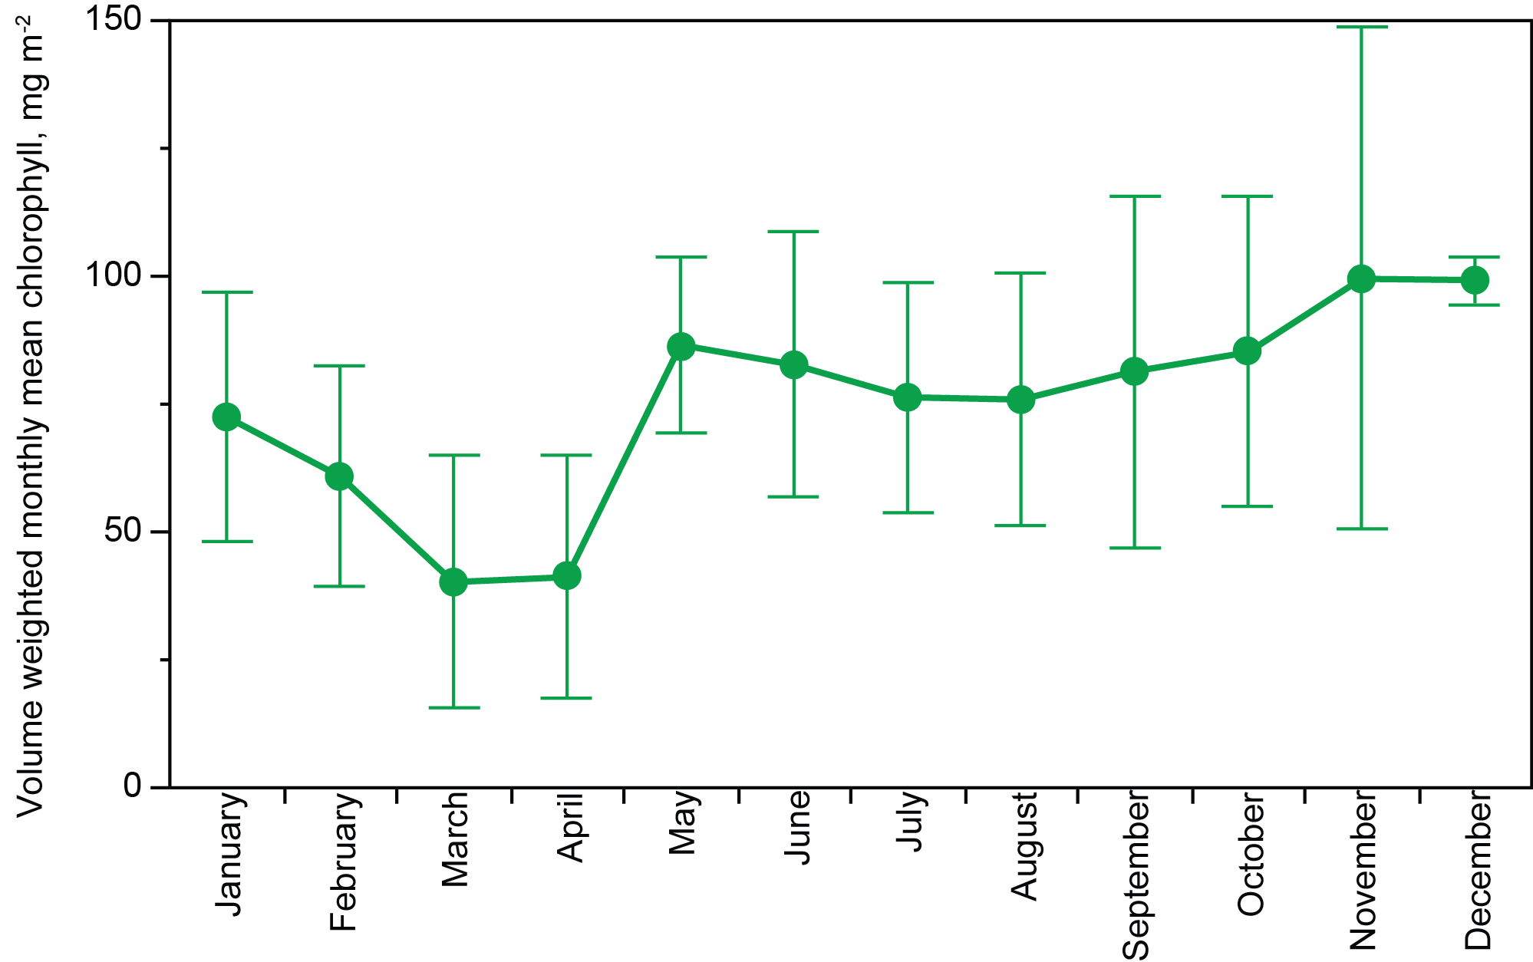
Figure 20. Mean chlorophyll per unit area, full water column, for all months 1984-2016.

Photosynthesis, Dissolved Oxygen, Respiration
Measurements over four years show that net primary production was low under ice and during ice melt until May, when water column stabilization began (Figure 21). Net production averaged ~400 mg C m⁻² d⁻¹ between the middle of May and the end of October, but production showed some depression between the middle of August and the middle of September. As the mixed layer began thickening in September, photosynthesis per unit area increased until mixing depth exceeded 20 m (October), then declined as the lake moved toward full mixing.
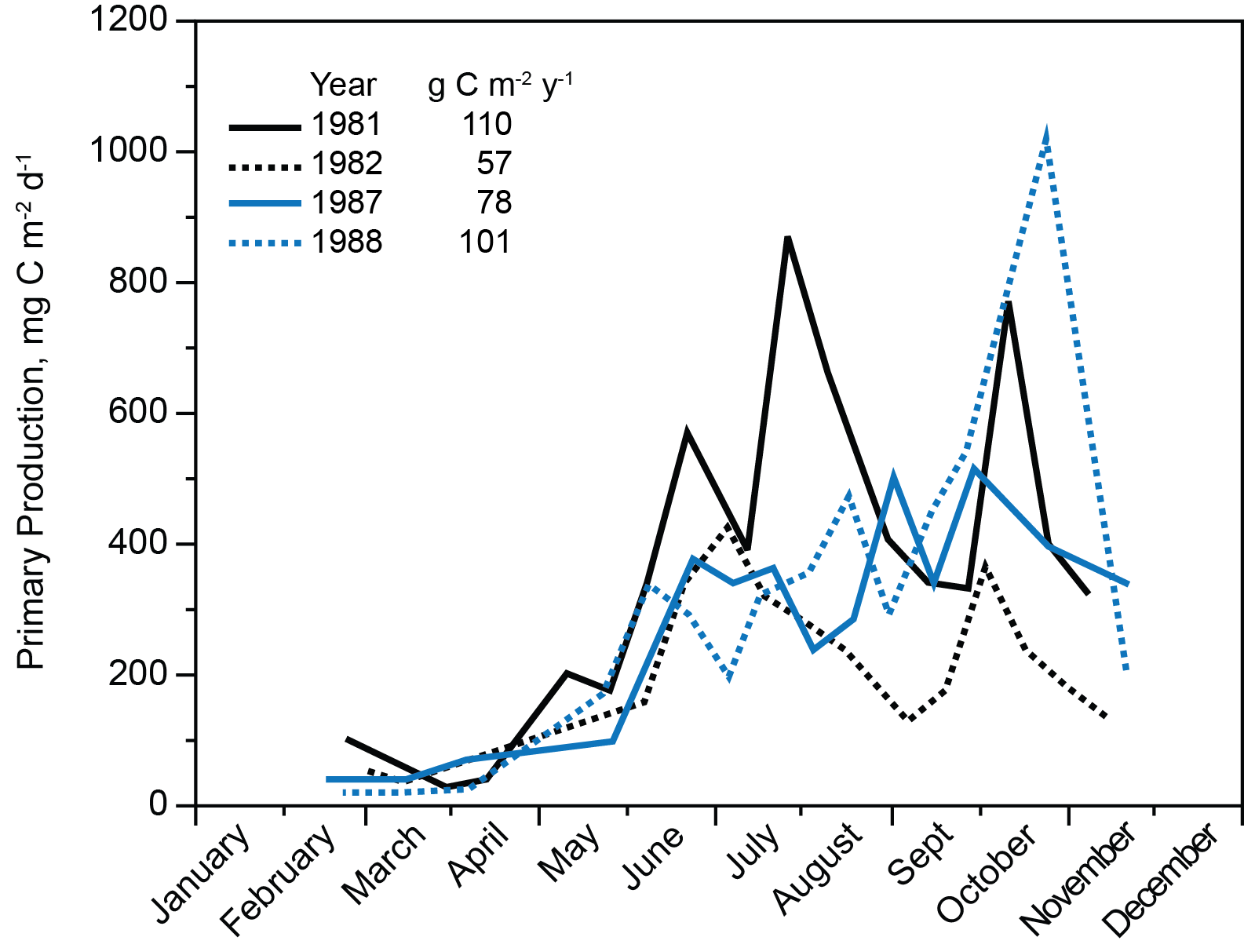
Figure 21. Net primary production per unit area in Lake Dillon for four years. Redrawn from Lewis et al. 1984, Morris and Lewis, 1992.

Mean minimum interannual oxygen concentrations for the hypolimnion were above 5 mg L⁻¹ (Figure 22); for individual dates across all years the minimum was near 4 mg L⁻¹. Under early ice cover, from the middle of December through January, the upper water column accumulated oxygen through photosynthesis at 0-15 m, but lost oxygen below 15 m (Figure 22). Later, under ice, in February and March, concentrations of dissolved oxygen declined at all depths, and added oxygen under early ice cover declined, probably because snow accumulation in late winter causes greatly reduced PAR beneath the ice.
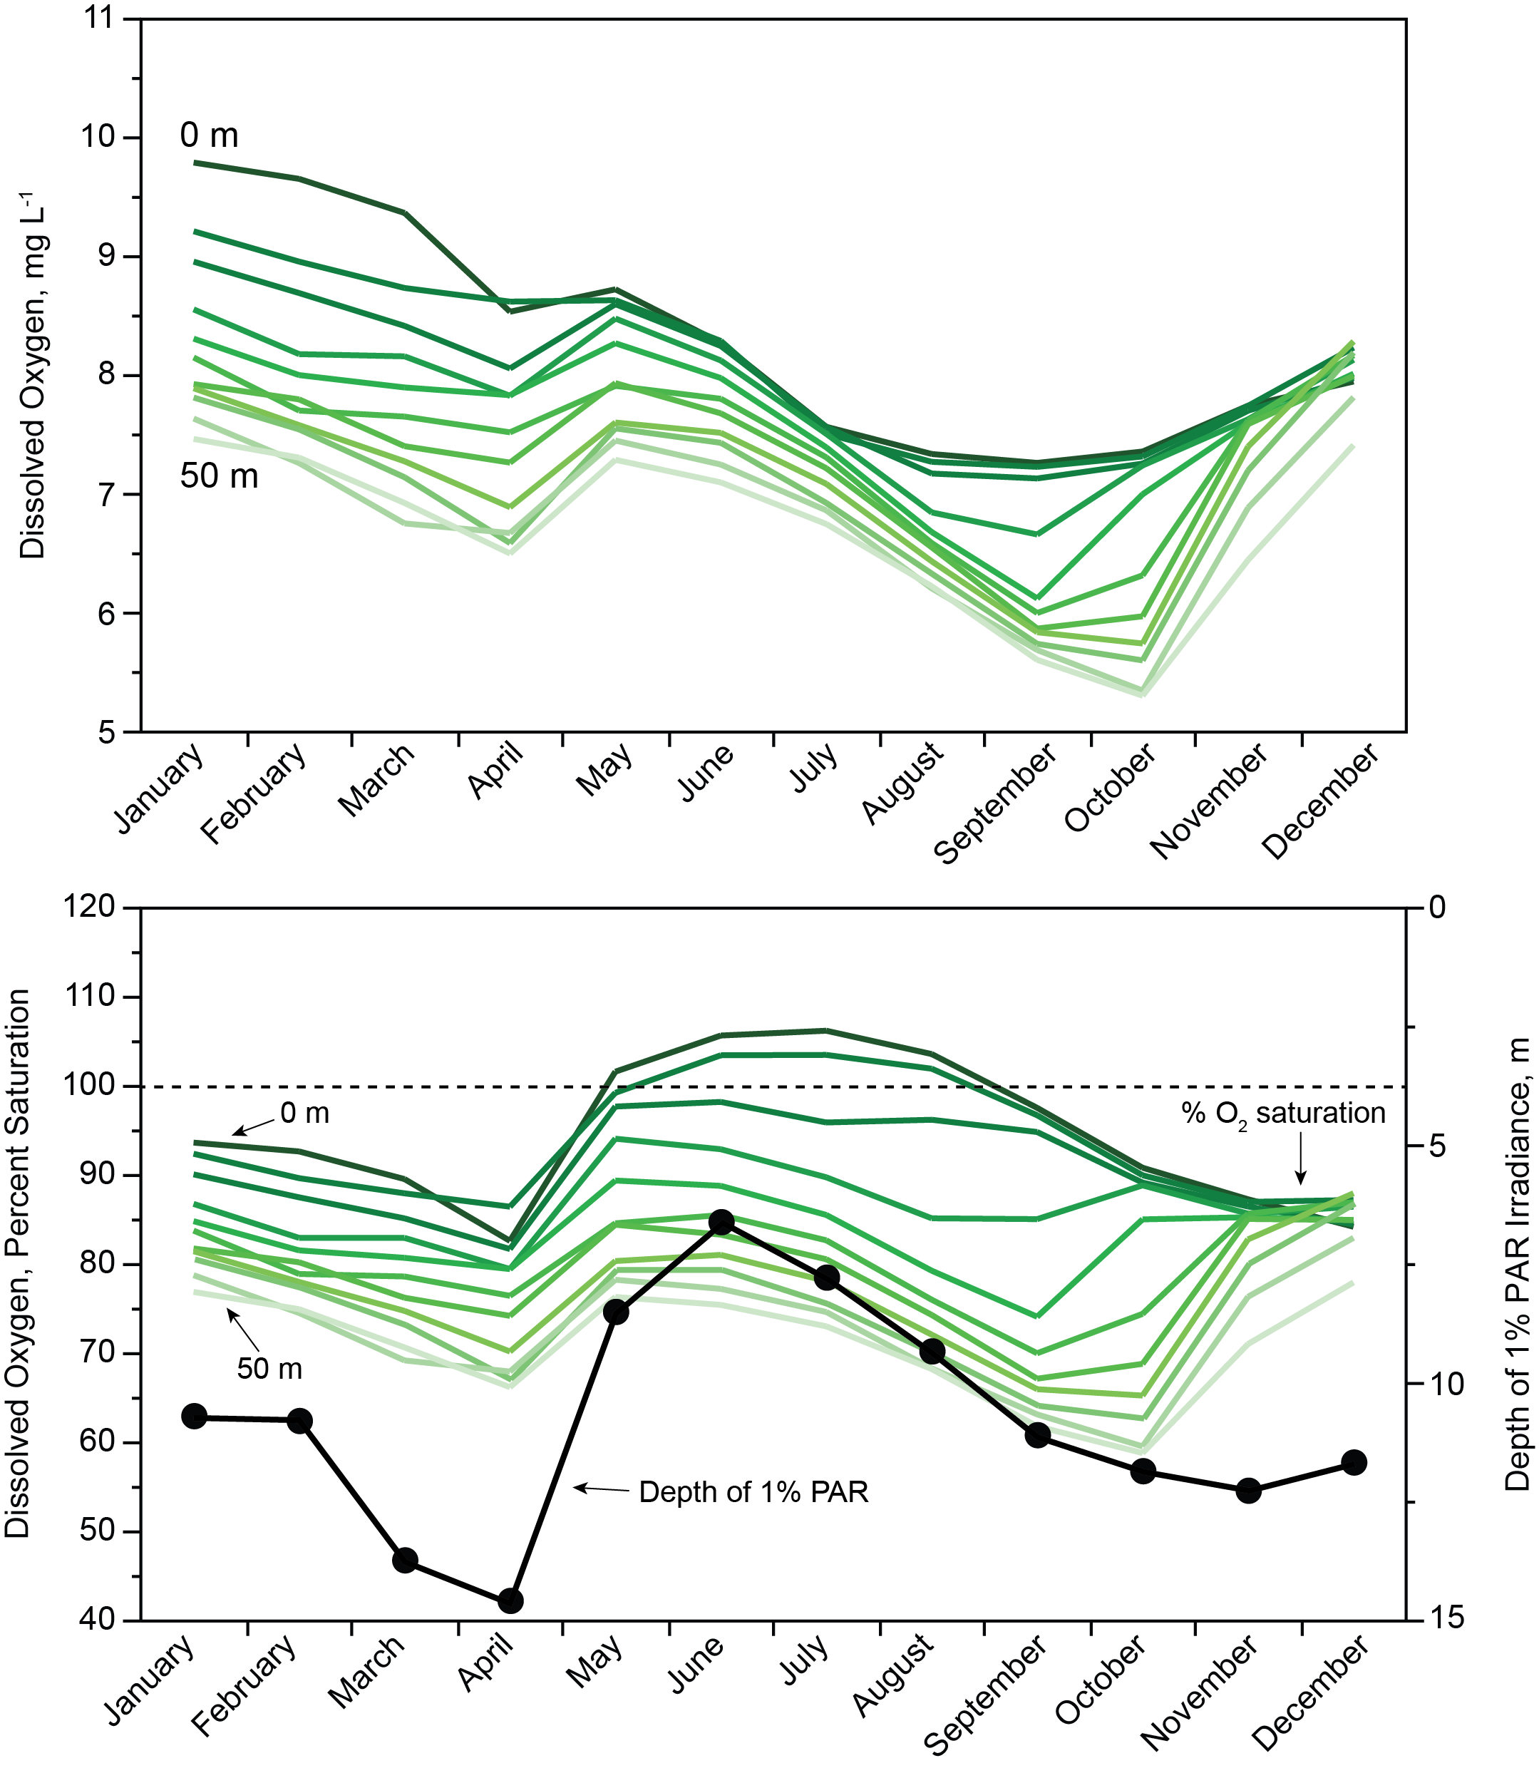
Figure 22. Above: mean dissolved oxygen concentrations by depth. Below: monthly mean % saturation of dissolved oxygen for 1984-2016 at 5 m increments from 0-50 m in Lake Dillon, and mean depth of 1% surface PAR over the same interval.
The lake was undersaturated with oxygen at all depths during fall mixing and under ice (Figure 22). Upward movement of percent saturation in April was caused by reaeration immediately after ice off. In May and extending through August, percent saturation moved above 100% for the top 10 m, indicating dominance of net photosynthesis over respiration in the mixed layer. The positive effect of net photosynthesis on percent saturation began to decline at the end of August, when oxygen production was overtaken by entrainment of water below the August thermocline as the mixed layer began to thicken.
PAR was sufficient to support positive net photosynthesis of algae in the mixed layer until the layer thickened just prior to fall mixing (Figure 22). Even in June, at the height of light extinction caused by turbidity associated with inflowing surface water, the upper seven meters of the water column were exposed to solar irradiance greater than or equal to 1% surface PAR. Secchi depth measurements were taken through a hole in the ice do not reflect shading by ice cover; under ice after mid-February and during full mixing, PAR deficiency suppressed net photosynthesis.
The decline of oxygen concentrations in deep water that began in June and extended into the middle of October supports an estimate of respiration. The rate of decline below 20 m depth was 0.02 mg O₂ L⁻¹ d⁻¹; loss of oxygen under ice below 20 m showed a similar slope. These low oxygen depletion rates are explained by the refractory nature of allochthonous DOC in the hypolimnion of the lake. Labile DOC released from phytoplankton was rapidly metastasized by bacteria in the epilimnion (Morris and Lewis 1982).

Phytoplankton Community Composition
Phytoplankton from the mixed layer were counted on all sampling dates for 1992-2015 (1996-1998 missing); species also were scored by abundance categories rather than species counts in 1981-1982. Abundances were clustered by a moving average of three years for assessment of temporal abundance trends (Table 2).
 | Rank
Taxon | 2013-2015 | 1992-1994 | 1992-2015 | Pattern
Aphanothece clathrata (C) | 1 | 92 | 1 | ID
Chrysochromulina parva | 2 | 12 | 4 | CH
Aphanocapsa conferta | 3 | 93 | 7 | I
Dactylococcopsis sp. | 4 | 35 | 12 | NT
Synedra radians | 5 | 2 | 5 | D
Chlorella minutissima | 6 | 11 | 3 | ID
Discostella (Cyclotella) glomerata | 7 | 94 | 22 | D
Bitrichia ollula | 8 | 49 | 11 | ID
Cyanobium sp. | 9 | 95 | 13 | I
Dinobryon divergens (S) | 10 | 81 | 21 | I
Urosolenia (Rhizosolenia) eriensis (C) | 11 | 5 | 6 | D
Chroococcus dispersus | 12 | 96 | 44 | NT
Synechococcus capitatus (C) | 13 | 38 | 50 | NT
Planktolyngbya limnetica (C) | 14 | 39 | 33 | NT
Asterionella formosa (C) | 15 | 18 | 24 | D
Dinobryon cyclindricum var. alpinium (S) | 16 | 23 | 32 | NT
Synedra delicatissima var. angustissima | 17 | 22 | 26 | D
Kathablepharis sp. | 18 | 97 | 35 | I
Synedra rumpens var. familiaris (C) | 19 | 76 | 14 | ID
Cosmarium tenue var. depressum (C) | 20 | 98 | 98 | I

Table 2. Top 20 phytoplankton species of Lake Dillon for the most recent interval (2013-2015), the earliest time span (1992-1994), and the entire time span (1992-2015) as determined by abundance of cells and rank of the same species in 1984, and mean ranks for each as well as trends in rank: I = increase, D = decrease, CH = consistently high, NT = no trend. Letters in parentheses indicate abundance of genera in 1981-1982, prior to reduction of phytoplankton biomass by suppression of SRP. C = common, S = secondary, present but not abundant.

The cumulative record shows 252 species; the median number detected per year was 67. Community composition at the species and genus level changed greatly over the study interval. The 10 most abundant species for 2013-2015 included only one of the most abundant species for 1992-1994 (Table 2). Strong contrasts applied also to genera. Only one genus from 1981-1982, prior to suppression of dissolved P, was among the top 10 group in 1992, following tertiary treatment. Only two of the 10 most abundant genera in recent years were among the 10 most abundant genera for the earliest years. From 1992-2015, the top 20 species included 5 that increased, 5 that decreased (all diatoms), one that showed consistently high rank (Chrysochromulina parva), 4 that decreased and increased, and 5 that showed no trend. Superimposed on these patterns was a great deal of interannual variation in rank among species, including brief strong declines or peaks (1-3 years) in abundance for a number of taxa.
Figure 23 shows abundances as cell counts for selected taxa. Absolute abundances are related in part to cell size, e.g., Aphanocapsa has a cell volume of ~1 μm³, whereas Synedra has a cell volume of ~500 μm³; the emphasis here is on change in abundance. While the community as a whole showed secular change in the form of shifting dominance that deviated progressively from the initial composition, individual taxa showed wide interannual variation in abundance.
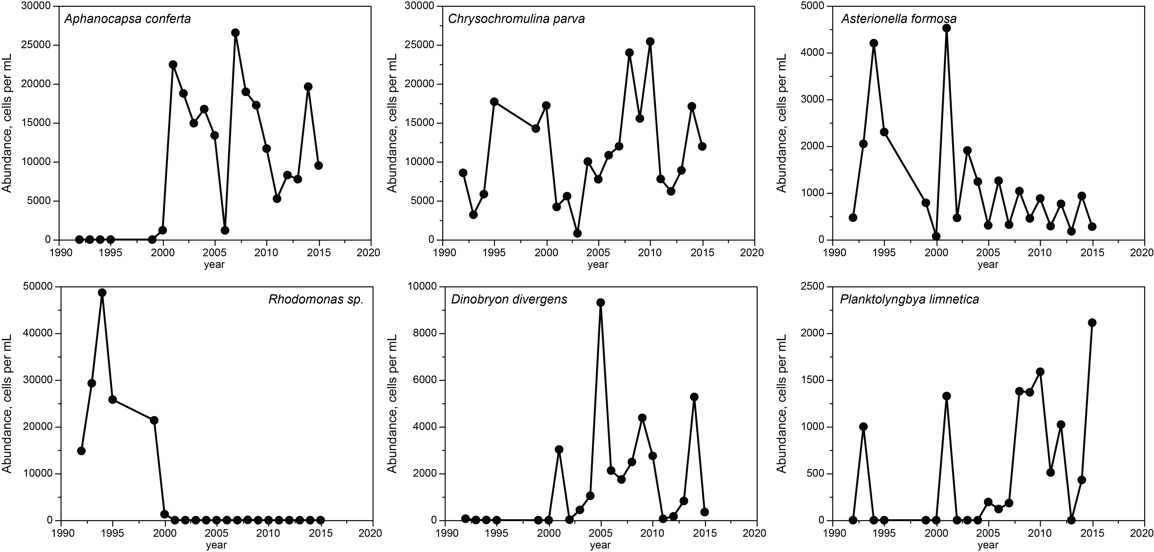
Figure 23. Numerical abundance (cells per mL) of phytoplankton taxa showing examples of species showing decline, increase, and brief, dominant peaks or declines.
Concurrent with constant interannual change in phytoplankton species composition was a decline in annual mean cell count (70%, Figure 24). Over the same interval, chlorophyll declined (42%, Figure 6), which indicates that mean cell size increased slightly with oligotrophication (~1.6x).
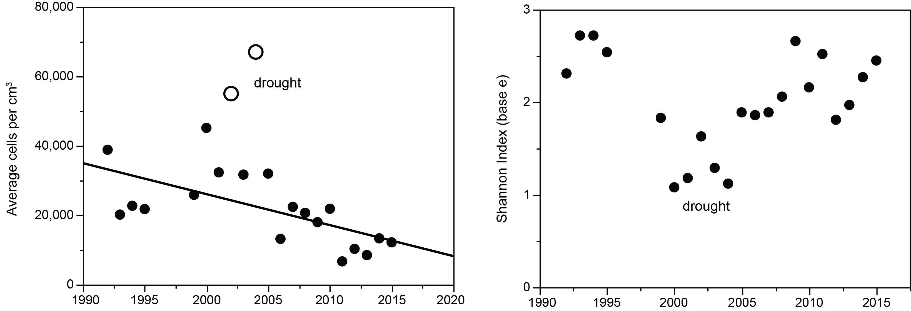
Figure 24. Left: Incremental change in annual average mean abundance of cells for phytoplankton in Lake Dillon, 1992-2015, r² = 0.40, p = 0.003 (two drought years excluded). Right: diversity of phytoplankton in Lake Dillon, 1992-2015.

The Shannon diversity index showed mean diversity of 2.0 (base e) and no secular trend, but a strong suppression of diversity in years 2000-2005, concurrent with a rise in dominance of cyanobacteria during drought. The diversity pattern for species was caused mainly by changes in evenness rather than species richness, which showed no trend and only moderate variance (mean 64 species per year, SD 11). At the division level, abundances declined over the entire sampling interval for most taxa: diatoms, chlorophytes, chrysophytes, and cryptophytes, as reflected in decline of annual average cells per unit volume (Figure 24). Haptophytes remained almost stable except for a dip in 2000-2005, when cyanophytes showed a peak. Dinophytes and euglenophytes were too scarce to be scored reliably.

Zooplankton
Zooplankton populations of Lake Dillon were not sampled on an annual basis over the entire study interval. In 1981, a 12-month study of zooplankton in Lake Dillon showed that more than 99% of individuals in the zooplankton population consisted of four taxa: Polyarthra vulgaris, Keratella cochlearis, Keratella quadrata, and Diacyclops bicuspidatus (Lewis et al. 1984). Daphnia and Bosmina were present, but in very small numbers. Mysis diluviana, sampled separately by Nelson (1981), also was present in significant abundance. Mysis was introduced in 1970 (Nesler 1986); a strong population was present after 1975 (mean for 1991-2009, 261 individuals per m²; Martinez et al. 2010). Daphnia (mostly D. galeata) had been abundant prior to 1970 (Nelson 1981), its subsequent scarcity indicates that Mysis caused an extreme reduction of Daphnia that persisted over the 35-year study interval, although a few years showed isolated sporadic occurrence of moderate abundance for Daphnia (e.g., 10-15 L⁻¹ Martinez et al. 2010).
The 1981 study showed a September peak for zooplankton biomass of approximately 800 μg L⁻¹ wet mass within the top 20 m (Figure 25). The median for the growing season (June-October) was ~400 μg L⁻¹; winter populations often were small, but bursts of Daphnia near the ice cover occurred in multiple years. The median abundance of copepods during the growing season was approximately 30 L⁻¹ (adults and copepodids; nauplii had nearly the same abundance but low biomass). Rotifers had a median abundance of ~400 L⁻¹, but contributed minimally to biomass (~10%).
Martinez et al. (2010) sampled zooplankton once per year in most years for 1991-2009. Johnson (personal communication 2017) also sampled zooplankton at least once annually in most years for 1993-2015. Both used a metered net with a mesh of 154 μm. These two sources report a median abundance of ~25 adult and subadult crustacean zooplankton L⁻¹ (nauplii and rotifers not included; Martinez et al. had lower estimates, Johnson had higher estimates). Bosmina showed a gradual rise in population density to ~25 individuals L⁻¹ in 2014 and 2015 (unpublished data, Brett Johnson 2017). A more abrupt surge in abundance of Diacyclops also occurred, resulting in a doubling of its abundance in 2014-2015 (Johnson 2017). The combined results for all years, 1991-2015, were similar to those for 1981. Both of the multiyear sampling programs showed great variation interannually in zooplankton abundance (coefficient of variation ~50% across years). There were no secular trends in total abundance, which was greatest in the middle years of the 35-year interval.
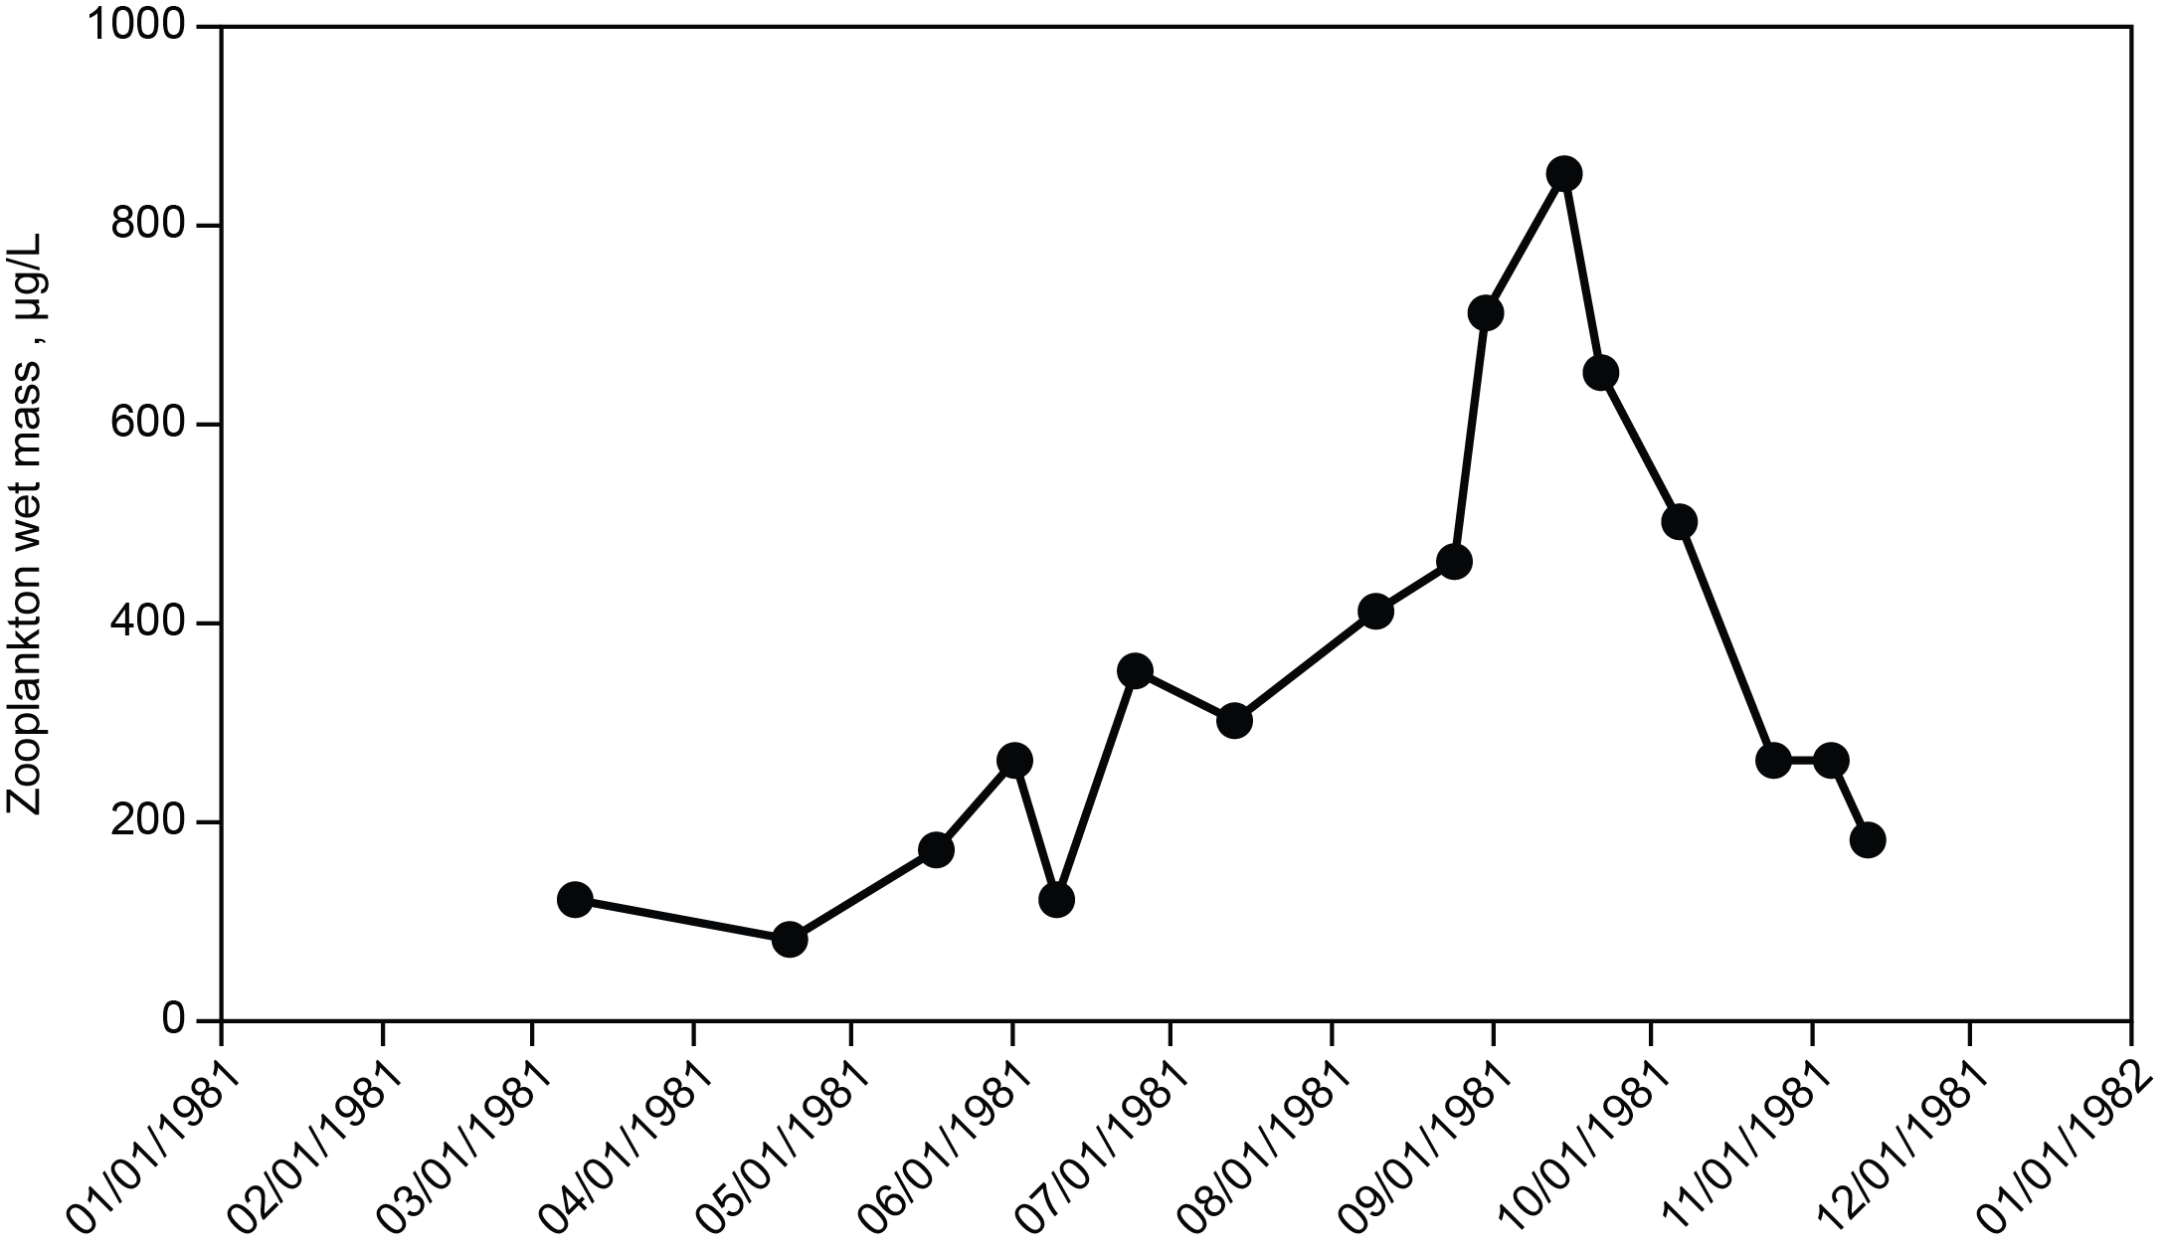
Figure 25.Wet mass abundance of total zooplankton in 1981 (corrected for sampling efficiency of the tow net; redrawn from Lewis et al. 1984).

Discussion
Secular Decline in Phytoplankton Biomass
The abrupt decline in phytoplankton biomass of 1982-1984 coincided with reduced loading of total P, but the second, more gradual, period of decline (1996-2016) was not coincident with decrease in total P loading (Figure 16). Factors other than P must be considered for both periods of biomass suppression, but other factors show no indication of potential to have suppressed algal biomass for either of the two periods of decline. Nitrogen deficiency was not implicated at any time because DIN loading was not reduced when total P loading was reduced in 1982-1984, and increased sunstantially subsequent to 1984 (Figure 14). Factors other than nutrients that could explain decline in phytoplankton, including hydrology, PAR availability, and herbivory, failed to show a secular trend and had low capacity to suppress biomass in Lake Dillon. Water temperature did show secular warming (2.5 °C mixed layer over 35 years, Lewis et al. 2019), but warming did not produce changes in mixed layer thickness or duration of ice cover, either of which could have affected phytoplankton (e.g., Berger et al. 2007). Warmth can be assumed to have caused metabolic acceleration of algae (Reynolds 2006, Domis et al. 2014), but this effect offers no mechanism for progressive decline in biomass, and would have increased metabolic rates by only ~20% over the study interval. For lakes generally, suppression of production or biomass that follow warming correspond to warmth that exceeds an optimal temperature (Butterwick et al. 2005), which is unlikely for Lake Dillon given its low maximum temperatures (~17 °C: Lewis et al. 2019).
In a study of maximum primary production per unit chlorophyll over 31 years of warming and oligotrophication for Lake Geneva, Tadonléke (2010) showed that warming was associated with increased production when total P was >22 μg/L, but had a repressive effect at lower concentrations consistent with oligotrophication, but the generality of the finding is not clear. Anneville et al. (2002) showed that oligotrophication was accompanied by an increase in algal biomass corresponding to a shift in species composition toward taxa with larger cells. Given that larger cells generally have lower metabolic rates (Banse 1976, Reynolds 2006), decline in P_{max} per unit chlorophyll could be consistent with a shift toward higher amounts of chlorophyll a associated with larger cells in response to oligotrophication. For Lake Dillon, decline in phytoplankton biomass was concurrent with a modest increase in cell size, but algal biomass decreased.
An interpretation of P as the cause of the two periods of phytoplankton biomass suppression (1982-1984, 1996-2016) can be based trends in BAP external to phytoplankton rather than total P. External BAP for present purposes consists of SRP and an unknown fraction of total dissolved P that is not SRP, calculated as TDP-SRP (sometimes designated dissolved organic P). The relative availability of P species is complex and not fully resolved (Elkholm and Krogerus 2003). Therefore, external BAP must be estimated for statistical purposes as SRP (probably a small underestimate) or as TDP (probably a small overestimate; Boström et al. 1988, Ekholm and Krolgerus 2003).
Because secondary municipal effluent reaching Lake Dillon had much higher SRP/TP and TDP/TP ratios than the combined watershed sources of total P, tertiary treatment had a disproportionately large effect in reducing the loading of SRP and TDP for Lake Dillon. The TDP:TP loading for the lake in 1981-1982 was 72%; for 1985-1995; following tertiary treatment, the ratio was 47%. The decline in TDP load following implementation of tertiary P treatment (68%) was large, as was the corresponding decline in algal biomass (46%). Therefore, the data are consistent with the hypothesis that the early chlorophyll suppression was caused specifically by reduction in BAP caused by tertiary P treatment.
For 1996-2016, phytoplankton biomass showed a significant decline coinciding with Phase 3 of the P control program, during which failing septic P sources were eliminated progressively across years at locations that could be served by sewer connections to tertiary wastewater treatment plants. Significant decline in concentrations of SRP (Table 3) occurred in the Blue River (54%) and in the Snake River (53%). Significant decline also occurred for TDP in the Blue River, which was ~50% by SRP. There was no trend in TDP or SRP for Tenmile Creek, probably because the ratio of water discharge to septic conversions for this watershed was too high to allow quantification of temporal change.
 |  | Mean, μg L⁻¹ | Initial, μg L⁻¹ | Change, μg L⁻¹ | r² | p
SRP
 | Blue River | 1.7 | 2.4 | -1.3 | 0.69 | <0.01
 | Snake River | 1.2 | 1.7 | -0.9 | 0.59 | <0.01
 | Tenmile Creek | 1.1 | 1.1 | 0.0 | - | NS
 | Lake | 0.7 | 0.7 | 0.0 | - | NS
TDP
 | Blue River | 3.0 | 3.6 | -1.2 | 0.65 | <0.01
 | Snake River | 2.3 | 2.3 | 0.0 | - | NS
 | Tenmile Creek | 2.8 | 2.8 | 0.0 | - | NS
 | Lake | 2.8 | 3.7 | -1.7 | 0.45 | <0.01

Table 3. SRP and TDP for Lake Dillon and its three river tributaries, given as a mean for 1996-2016, and degree of change over the same interval as determined from regression analysis.

Concentrations of SRP for 1996-2016 in the lake did not decline in response to decreased loading, probably because SRP removal by phytoplankton was occurring at maximum efficiency over the entire study interval, as shown by consistently very low SRP mixed layer concentrations in the growing season. TDP declined, possibly because of increased conversion of the external non SRP fraction by phytoplankton as a result of increased SRP scarcity (Jones 1972, Rengefors et al. 2001, Elkholm and Krogerus 2003).
As shown by Lake Dillon and enrichment studies in general (Reynolds and Davies 2001, Elser et al. 2007), SRP has high potential for regulation of algal biomass. For Lake Dillon prior to tertiary treatment, the ratio of SRP to total P was high in secondary municipal effluent, as expected (Bali and Gueddari 2015). Secondary domestic wastewater is likely to contain an even higher proportion of SRP than untreated wastewater because secondary treatment causes conversion of polyphosphate and organic P to SRP (Bali and Gueddari 2015). Therefore, control of P by tertiary treatment of secondary effluent (Li and Brett 2015) is especially effective in restricting algal biomass. Also, septic systems, if impaired or failing, can be a significant source of SRP for oligotrophic lakes, as shown for the Lake Dillon watershed (Lewis et al. 1984). Soil disturbance and urban runoff also are sources of aquatic P (Dodds and Oakes 2004), but may in some cases be insignificant for algal populations because of their low BAP/TP ratios (Sonzogni et al. 1982, Reynolds and Davies 2001, Ekholm and Krogerus 2003, Jarvie et al. 2006). Studies of the Lake Dillon watershed show that nonpoint sources excluding septic systems accounted for only 70 kg y⁻¹ of anthropogenic nonpoint loading of P, whereas municipal effluent prior to tertiary treatment accounted for 825 kg y⁻¹ (Lewis et al. 1984).

Fate of Phytoplankton Production
As shown by monitoring data, grazing and loss of biomass from the mixed layer through spillway overflow removed only a small portion of net primary production from the lake. A third loss, caused by sinking of phytoplankton cells, can be estimated from the literature. The largest of dominant taxa in Lake Dillon would sink at rates no greater than 1 m d⁻¹ (Reynolds 2006); the average sinking rate for biomass typically is much lower. Reynolds (1989) showed that a sinking rate of 1 m d⁻¹ for large cells corresponds to ~10% biomass loss per day from an epilimnion of 10 m thickness, which implies to <5% per day loss of mixed algal cell types to sinking in Lake Dillon.
Grazing losses of phytoplankton can be estimated from zooplankton abundance. For 1981, the measured mean biomass for zooplankton, June-October, was 400 μg L⁻¹ wet mass (Lewis et al. 1984). The expected wet biomass of the zooplankton population during the growing season can be estimated from the relationship between zooplankton and phytoplankton in a large group of lakes spanning a wide trophic range (McCauley and Kalff 1981, Equation 1): 4400 μg L⁻¹ wet mass for a lake with chlorophyll of ~ 4 μg L⁻¹, such as Lake Dillon after 1984. Thus, the implicit grazing loss for Lake Dillon was very low.
A direct estimate of grazing rate can be based on characteristic filtration rates for lakes where grazing is dominated by copepods and cladocerans: at most 2000 mL mg⁻¹ dry weight d⁻¹ (Jassby and Goldman 1974). Grazing at this rate would have cleared ~40% of net production per day. The low grazing rate in Lake Dillon explains why there was no suppression of phytoplankton biomass at the end of spring, in contrast with many lakes (Berger et al. 2007).
Loss rates for all mechanisms that can be estimated (grazing, outflow, sinking) account collectively for ~50% of primary production. Loss unaccounted for, quantified as a residual of documented losses, appears to be accounted for by cell death consisting of an unknown combination of programmed cell death (PCD or apoptosis, Bidle and Falkowski 2004), mortality caused by cell specific biological agents (e.g., viruses, bacteria), or environmentally induced death caused by lack of nutrients or other stresses (Franklin et al. 2006). These losses will be referred to here collectively as “endogenous mortality.”
A problem with quantifying a mortality mechanism through computation of a residual is the cumulation of error in all estimates that are antecedent to the residual (Jassby and Goldman 1974). For Lake Dillon, however, losses that might have affected the estimate of a residual for loss of phytoplankton biomass were small. Grazing was strongly suppressed in Lake Dillon by the introduced predator Mysis, hydraulic loss of biomass from the mixed layer was suppressed by minimization of spillway overflow as a means of conserving the storage volume of water in the lake, and sinking was a very small loss relative to production. Because errors in estimating these three factors would not likely account for the size of the residual, endogenous mortality is strongly indicated.
Endogenous mortality has been observed (Lund et al. 1963) and quantified (Agusti et al. 2006) in field populations of lakes; losses of this type are especially evident in algal blooms and in laboratory cultures (Franklin et al. 2006). Lysis of phytoplankton cells appears to account for a high percentage of dissolved organic carbon release in oligotrophic marine waters (Agusti and Duarte 2013). For Lake Dillon, the significance of endogenous mortality lies in consistent, significant loss of phytoplankton biomass in the mixed layer.
The closest comparison for Lake Dillon algal mortality is a study by Jassby and Goldman (1974) of Castle Lake, which had primary production very similar to that of Lake Dillon and showed epilimnetic endogenous mortality of 20-60%, as computed from all other losses. A difference between Castle Lake and Lake Dillon is grazing loss for phytoplankton, which was greater in Castle Lake than in Lake Dillon. For Lake Dillon, endogenous mortality may have been magnified by low loss of biomass to grazing.
Dynamics of phytoplankton below the mixed layer in Lake Dillon also show some unexpected features. Endogenous loss of phytoplankton was ~50% within the metalimnion, but <10% in the hypolimnion (Figure 17). As indicated by sinking rates and consistency of biomass in the water column during stratification, the cells remained in the hypolimnion over deep water (e.g., 40 m) for at least a month. These cells originated from the mixed layer at a rate of approximately 0.6 μg L⁻¹ chlorophyll per day. During the interval of descent toward the sediments, the cells appear to have been viable, as indicated by low phaeophytin corrections for chlorophyll measurements. Cells at depth showed no evidence of significant endogenous mortality; their abundance was steady with depth during stratification. The explanation for differences in mortality between the deep water and surface populations of phytoplankton cells is not obvious, but the biochemical processes of algae in these two very different environments could be influenced by suppression of metabolic rate for cells descending to an environment that is aphotic and cold as compared with the environment of cells nearer to the surface.
High endogenous mortality for phytoplankton in Lake Dillon would have provided a consistent source of labile organic matter in support of microbial metabolism. Morris and Lewis (1992) showed that microbial growth rates were far below optimal rates that could be achieved experimentally by enrichment in situ. Enrichments showed that bacteria consistently had a strong growth response to addition of SRP, but almost never had a growth response to addition of labile organic matter. Release of dissolved organic matter through endogenous cell mortality combined with suppression of microbial growth by P deficiency could account for the notable increase in DOC during the last part of the growing season (Figure 5).

Secular Changes in Community Composition of Phytoplankton
Phytoplankton taxa or functionally defined groups can be classified to some degree according to their response to specific physical and chemical features of their environment (Reynolds 2006, Ptacnik et al. 2009, Lewis 1986). Classifications of this type may explain interannual change in composition of phytoplankton communities in response to climate change or change in trophic state. In Lake Dillon, only two environmental features, temperature and availability of BAP, showed secular trends. There is presently no basis for predicting secular trends in species composition in response to temperature changes of the magnitude observed in a cold lake such as Dillon (trend = 2.5 °C over 35 years). The data suggest, however, that a slow decline in BAP, the likely cause of a secular downward trend in chlorophyll a, for Lake Dillon was also the cause of changes in phytoplankton community composition. This conclusion seems contrary to the accepted principle that changes in phytoplankton composition are explained by multiple, well known factors under conditions of disequilibrium (Hutchinson 1961, Reynolds 2006, Interlandi and Kilham 2001) through mechanisms of meterological irregularity (Finger et al. 2013), chaos, or spatial heterogeneity at large or small scales (Huisman and Weissing 1999, Ptacnik et al. 2010). The Lake Dillon data suggest that P could have had a large, singular influence on community composition of biomass over an interannual time scale.
Anneville et al. (2005) concluded that decline in P concentrations of European perialpine lakes caused synchronous changes in phytoplankton community composition, even though changes in phytoplankton biomass were negligible. Their data show that biomass was stabilized by shifts from small to large taxa in response to decreasing P, or by other factors including grazing (Jørgensen and De Bernardi 1998), whereas community composition did not show comparable resilience. In at least some lakes, changes in composition may be in some respects predictable. For example, in large lakes of northern Europe, chrysophytes, pinnate diatoms, and cyanobacteria sequentially dominate communities as algal abundance increases in response to nutrient enrichment (Ptacnik et al. 2008). Other secular changes may be forecast on the basis of adaptations that are advantageous at low concentrations of bioavailable P, e.g., an increase in abundance of phagotrophic taxa (Jeppesen et al. 2002). Secular changes in Lake Dillon do align temporally to some degree with taxonomy at the division level but much less coherently at the species level. Decline of diatoms and chlorophytes in Lake Dillon could have been a simple outcome of P stress, but simultaneous decline of cryptophytes and chrysophytes is not consistent with hypothetical advantages for phagotrophs when external BAP is scarce. A burst of cyanobacterial abundances in 2000-2005 coincided with drought that lowered water levels to an extreme extent. Wind generated currents reached the bottom of the water column, which increased concentrations of P in the water column, to which cyanobacteria apparently responded, but other taxa did not show clear responses except for haptophytes, which were temporarily suppressed. The most parsimonious explanation for secular change in species composition of Lake Dillon, which has an unusually narrow range of factors that could explain trends in phytoplankton, is response to decline in external BAP.

General Conclusions
The long-term data record greatly facilitated detection of the importance of secular change in algal biomass as an indicator of cause and effect relationships between algal biomass and the presence of a trend caused by a single environmental factor (soluble P), and not by other factors that might cause such a trend, thus simplifying the analysis of cause and effect and leading to a more secure conclusion than would have been possible on the basis of a short data record. A second provocative aspect of the long term data record, which would not have been evident from a short record, is the extensive change in phytoplankton composition over decades, when the only potent change in environmental factors that might affect phytoplankton was the availability of SRP. No final conclusions are possible about this observation, but the implication is that progressive small changes in a single variable may cause large interannual changes in phytoplankton composition even though changes in phytoplankton composition typically are viewed on a seasonal basis, which focuses attention on the interacting roles of multiple variables that affect growth and decline of individual species populations in a specific growing season. The long term perspective may be qualitatively different, as it was for Lake Dillon, where the importance of seasonal changes was superseded over decades by nonseasonal change in a single factor, external BAP.

Acknowledgements
We thank the Summit Water Quality Committee and the Denver Water Department for their support of Lake Dillon monitoring, and Brett Johnson for information on zooplankton.

Agusti, S., E. Alou, M.V. Hoyer, T.K. Frazer and D.E. Canfield. 2006. Cell death in lake phytoplankton communities. Freshwater Biology 51:1496-1506.
Agusti, S., and C.M. Duarte. 2013. Phytoplankton lysis predicts dissolved organic carbon release in marine plankton. Biogeosciences 10:1259-1264.
Anneville, O. S. Gammeter, and D. Straile. 2005. Phosphorus decrease and climate variability: mediators of synchrony in phytoplankton changes among European peri-alpine lakes. Freshwater Biology 50:1731-1746.
Anneville, O., V. Ginot, and N. Angeli. 2002. Restoration of Lake Geneva: Expected versus observed responses of phytoplankton to decreases in phosphorus. Lakes and Reservoirs: Research and Management 7:67-80.
Anthony, J.L. and W.M. Lewis, Jr. 2012. Low boundary layer response and temperature dependence of nitrogen and phosphorus releases from oxic sediments of an oligotrophic lake. Aquatic Sciences 74:611-617.
APHA. 2005. Standard Methods for the Examination of Water and Wastewater. 21st Edition, American Public Health Association/American Water Works Association/Water Environment Federation, Washington DC.
Bali, M. and M. Gueddari. 2015. Removal of phosphorus from secondary effluents using infiltration-percolation process. Applied Water Science 9:54.
Banse, K. 1976. Rates of growth, respiration, and photosynthesis of unicellular algae as related to cell size – a review. Journal of Phycology 12:135-140.
Berger, S.A., S. Diehl, H. Stibor, et al. 2007. Water temperature and mixing depth affect timing and magnitude of events during spring succession of the plankton. Oecologia 150:643-654.
Bidle, K.D. and P.G. Falkowski. 2004. Cell death in planktonic, photosynthetic microorganisms. Nat. Rev. Microbiol. 2:643-655.
Boström, B., G. Persson, and B. Broberg. 1988. Bioavailability of different phosphorus forms in freshwater systems. Hydrobiologia 170(1):133-155.
Butterwick, C., S.I. Heaney, and J.F. Talling. 2005. Diversity in the influence of temperature on the growth rates of freshwater algae, and its ecological relevance. Freshwater Biology 50:291-300.
Dodds, W.K. and R.M. Oakes. 2004. A technique for establishing reference nutrient concentrations across watersheds affected by humans. Limnology and Oceanography: Methods 2:333-341.
Domis, L., D. Van de Waal, N.R. Helmsing, E.V. Donk, and W.M. Mooij. 2014. Community stoichiometry in a changing world: Combined effects of warming and eutrophication on phytoplankton dynamics. Ecology 95(6):1485-1495.
Edmonson, W.T. and J.T. Lehman. 1981. The effect of changes in the nutrient income on the condition of Lake Washington. Limnology and Oceanography 27:272-293.
Elkholm, P. and K. Krogerus. 2003. Determining algal-available phosphorus of differing origin: routine phosphorus analyses versus algal assays. Hydrobiologia 492:29-42.
Elser, J.J. et al. 2007. Global analysis of nitrogen and phosphorus limitation of primary producers in freshwater, marine and terrestrial ecosystems. Ecology letters 10:1-8.
Finger, D., A. Wüest, and P. Bossard. 2013. Effects of oligotrophication on primary production in peri-alpine lakes. Water Resources Research 49(8): 4700-4710.
Franklin, D.J., C.P.D. Brussaard, and J.A. Berges. 2006. What is the role and nature of programmed cell death in phytoplankton ecology? Eur. J. Phycol. 41:1-14.
Huisman, J. and F.J. Weissing. 1999. Biodiversity of plankton by species oscillations and chaos. Nature Letters. 402:407-410.
Hutchinson, G.E. 1961. The paradox of the plankton. American Naturalist 95:137-145.
Interlandi, S.J. and S.S. Kiham. 2001. Limiting resources and the regulation of diversity in phytoplankton communities. Ecology 82(5):1270-1282.
Jarvie, H.P., C. Neal, and P.J.A. Withers. 2006. Sewage-effluent phosphorus: A greater risk to river eutrophication than agricultural phosphorus? Science of the Total Environment 360:246-253.
Jassby A. and C.R. Goldman. 1974. Loss rates from a lake phytoplankton community. Limnology and Oceanography 19(4):618-627.
Jeppesen, E., J.P. Jensen, and M. Søndergaard. 2002. Response of phytoplankton, zooplankton, and fish to re-oligotrophication: An 11 year study of 23 Danish lakes. Aquatic Ecosystem Health and Management 5(1):31-43.
Jones, J.G. 1972. Studies on freshwater micro-organisms: phosphatase activity in lakes of differing degrees of eutrophication. Journal of Ecology 60(3):777-791.
Jørgensen, S.E. and R. De Bernardi. 1998. The use of structural dynamic models to explain successes and failures of biomanipulation. Hydrobiologia 379:147-158.
Kalff, J. 2002. Limnology. Prentice Hall, New Jersey. 592 pp.
Kaushal, S.S., W.M. Lewis, Jr., and J.H. McCutchan, Jr. 2006. Land Use Change and Nitrogen Enrichment of a Rocky Mountain Watershed. Ecological Applications 16(1): 299-312.
Kirk J.T.O. 1994. Light & photosynthesis in aquatic ecosystems. 2nd ed. New York (NY): Cambridge.
Lewis, W.M. Jr. and J.F. Saunders, III. 1979. Two new integrating samplers for zooplankton, phytoplankton, and water chemistry. Archiv fur Hydrobiologie 75: 244-249.
Lewis, W.M. Jr., J.F. Saunders, III, D.W. Crumpacker, Sr., and C. Brendecke. 1984. Eutrophication and Land Use: Lake Dillon, Colorado. Springer-Verlag, New York. 202 p.
Lewis, W.M. Jr. 1986. Phytoplankton succession in Lake Valencia, Venezuela. Hydrobiologia 138:189-203.
Lewis, W.M., Jr. 2011. Global primary production of lakes: 19th Baldi Memorial Lecture. Inland Waters 1:1-28.
Lewis, W.M., Jr., J.H. McCutchan, Jr. and J. Roberson. 2019. Effects of climatic change on temperature and thermal structure of a mountain reservoir. Water Resources Research 55(3):1989-1999.
Li, B. and M.T. Brett. 2015. The relationship between operational and bioavailable phosphorus fractions in effluents from advanced nutrient removal systems. Int. J. Environ. Sci. Technol. 12:3317-3328.
Lund, J.W.G., F.H.H. Mackereth, and C.H. Mortimer. 1963. Changes in depth and time of certain chemical and physical conditions and of the standing crop of Asterionella Formosa Hass. in the north basin of Windermere in 1947. Philosophical Transactions of the Royal Society of London 246:255-290.
Martinez, P.J, M.D. Gross, and E.M. Vigil. 2010. A compendium of crustacean zooplankton and Mysid Diluviana collections from selected Colorado reservoirs and lakes 1991-2009. Colorado Division of Wildlife Aquatic Wildlife Research. Special Report Number 82.
McCauley, E. and J. Kalff. 1981. Empirical relationships between phytoplankton and zooplankton biomass in lakes. Canadian Journal of Fisheries and Aquatic Sciences 38(4):458-463.
Morris, D.P. and W.M. Lewis, Jr. 1992. Nutrient limitation of bacterioplankton growth in Lake Dillon, Colorado. Limnology and Oceanography 37: 1179-1192.

Nelson, W. C. 1981. Large lake and reservoir limnological studies. Pages 6-8 in O. B. Cope, editor. Colorado Fisheries Research Review 1978-1980. Colorado Division of Wildlife, Fort Collins.

Nesler, T. P. 1986. Mysis-gamefish studies. Job Progress Report. Colorado Division of Wildlife, Federal Aid in Fish and Wildlife Restoration, Project F-83-R, Fort Collins. 99 pp.

Ptacnik, R., A.G. Solimini, and P. Brettum. 2009. Performance of a new phytoplankton composition metric along a eutrophic gradient in Nordic lakes. Hydrobiologia 633:75-82.
Ptacnik, R., L. Lepisto, E. Willen et al. 2008. Quantitative responses of lake phytoplankton to eutrophication in Northern Europe. Aquatic Ecology 42(2):227-236.
Ptacnik, R., T. Anderson, P. Brettum, L. Lepisto, and E. Willén. 2010. Regional species pools control community saturation in lake phytoplankton. Proc. R. Soc. B 277:3755-3764.
Rengefors, K., K. Pettersson, T. Blenckner, and D.M. Anderson. 2001. Species specific alkaline phosphatase activity in freshwater spring phytoplankton: Application of a novel method. Journal of Plankton Research 23(4):435-443.
Reynolds, C.S. 1989. Experimental manipulations of the phytoplankton periodicity in large limnetic enclosures in Blelham Tarn, English Lake District. Hydrobiologia 138:43-64.
Reynolds, C.S. 2006. The Ecology of Phytoplankton (Ecology, Biodiversity and Conservation). Cambridge: Cambridge University Press.
Reynolds, C.S. and P.S. Davies. 2001. Sources and bioavailability of phosphorus fractions in freshwaters: A British perspective. Biol. Rev. 76:27-64.
Solorzano, L. and J.H. Sharp. 1980. Determination of total dissolved phosphorus and particulate phosphorus in natural waters. Limnology and Oceanography 25(4):754-758.
Sonzogni, W.C., S.C. Chapra, D.E. Armstrong, T.J. Logan. 1982. Bioavailability of phosphorus input to lakes. J. Environ. Qual. 11:555-563.
Tadonléké, R.D. 2010. Evidence of warming effects on phytoplankton productivity rates and their dependence on eutrophication status. Limnology and Oceanography 55(3): 973-982.

